Modeling AND SiMULATION OF MagNETIC TRANSMISSION LINES

Muhammad Shamaas

ID # 2018-MS-EE-4



DEPARTMENT OF ELectrical Engineering

UNIVERSITY OF ENGINEERING AND TECHNOLOGY LAHORE

Contents

List of Figures 2

Abstract 3

Acknowledgements 4

1. Introduction to Solid State Magnetism 5

1.1. Nature of Magnetic Materials 6

1.2. AC Losses in Magnetic Materials 14

1.3. Literature Review 18

1.4. Outline 20

2. Wave Propagation in Magnetic Materials 21

2.1. Plane Wave Propagation 21

2.2. Power Flow Analysis 23

3. Magnetic Circuit Modeling 24

3.1. Reluctance Model 25

3.1.1. Application 26

3.2. Capacitance-Permeance Model 27

3.2.1. Application 29

3.3. Magnetic Transmission Line Model 31

3.3.1. Application 37

3.4. Summary 38

4. Computational Electromagnetics 39

4.1. Methods for solving Maxwell’s Equations 39

4.2. Time Domain Methods 40

4.3. Frequency Domain Methods 42

4.4. MEEP 43

5. Magnetic Transmission Line Simulation 47

5.1. Wideband Transformers 50

5.2. Electrical Circuit for Wideband Transformer 53

5.3. Magnetic Circuit for Wideband Transformer 55

5.4. Wideband Transformer Simulation in MEEP 62

6. Conclusion 64

7. References 65

8. Appendix 70

# List of Figures

Figure 1 7

Figure 2 8

Figure 3 11

Figure 4 11

Figure 5 12

Figure 6: Magnetization vs. Applied Field 12

Figure 7: Hysteresis Loop 13

Figure 8 14

Figure 9 16

Figure 10 16

Figure 11 24

Figure 12 25

Figure 13 27

Figure 14 32

Figure 15 33

Figure 16 36

Figure 17 42

Figure 18 48

Figure 19 55

Figure 20 56

Figure 21 57

Figure 22 66

# Abstract

Magnetic Transmission Line [Faria] is the dual counterpart of Electric Transmission Line. Its theory encompasses a diverse range of applications including Transformers [Dinulovic], Dynamic Machines [Erickson], Microwave Generators, Tuners, Couplers, Isolators, Power Dividers [Pozar] etc. Intrinsically, Magnetic Transmission Line [Faria] is made from a non-conducting magnetic material, with a high permeability. It transmits Magnetic Flux as the effective Magnetic charge. Time varying magnetic flux results in a Magnetic Displacement Current inside the Transmission Line. This produces a gradient Magnetic Field; with Fields Lines that spread radially outwards. The magnetic current and magnetic voltage due to this Magnetic Field is measured in Volts and Amperes respectively. Although, the operation of a Magnetic Transmission Line [Faria] does not involve electric charges, Magnetic Displacement Current produces an Electric Field with closed Field Lines encircling the Magnetic Transmission Line [Faria]. Together, the Electric and Magnetic Fields transmit Energy along the direction of propagation [Paul]. These relations were modeled using Maxwell’s Equations [Paul] and magnetic circuits to study the time and frequency domain behavior of Magnetic Transmission Lines [Faria]. Furthermore, Finite Difference Time Domain Electromagnetic Field Simulations [Sui] were carried out in MEEP [Oskooi] Simulator for anisotropic, inhomogeneous, non-linear Magnetic Transmission Lines [Li] [Faria] [Bragg].

The Magnetic Transmission Line [Faria] model is valuable for the design of Magnetic Elements like Inductors, Transformers and Filters [Dinulovic] [Erickson]. The conventional design of Magnetic Elements is an iterative procedure. There is no shortage of empirical formulas for estimating Magnetic Losses in Magnetic Cores [Erickson]. The literature derived formulas are specific for the particular Magnetic core shape and size. The procedure involves many approximations like uniform field inside core. The design involves hit and trial methods. The element is designed for particular frequency. The Magnetic Transmission Line [Faria] model can be extended to design accurate models for such magnetic elements [Erickson]. An example wideband transformer [Gustavsen] [Grecki] [Darraji] [Dinulovic] is designed with multiple outputs and a large bandwidth. The electromagnetic effects were compared with the results of the transmission line model.

# Acknowledgements

# 

# Introduction to Solid State Magnetism

The first chapter is dedicated to a brief review of the nature of Magnetic materials and the transmission of magnetic information using magnetic dipoles. Section 1.1. presents a summary of Magnetic Dipoles and Bulk Magnetization. Section 1.2. discusses the AC properties and losses of magnetic materials [Erickson]. Section 1.3. presents a literature review of Magnetic Transmission Lines [Faria] with major emphasis on the recent research on Giant Magnetoresistance, Magnetic Capacitance, Magnetic Memory [Khitun], Spintronic and Nanomagnetic Logic Devices [Leuenberger] [Imtaar] [Holynska] [Atulasimha] [Demokritov] [Eichwald] [Guimaraes].

Magnetic Transmission Lines [Faria] are designed to transmit electromagnetic energy using strong magnetic fields. They are made of magnetic materials having very high magnetic permeability and a strong affinity for magnetic flux. When an external magnetic field is applied, magnetic dipoles react to align with it. This large scale cooperation enhances the Magnetic Flux Density inside the magnetic material. When the applied field is varied, the changing Magnetic Flux Density transmits the magnetic information across the magnetic material [Cividjian]. This phenomenon is called Magnetic Transmission [Faria].

It is important to note that charge transport is not involved in magnetic communication. Isolated Magnetic charges do not exist and magnetic conduction current can never flow in a Magnetic Transmission Line [Faria]. Magnetic Transmission is only possible through the alignment of magnetic dipoles in response to a stimulating Magnetomotive Force. This is termed as Magnetic Displacement Current.

Magnetic Transmission does not involve the flow of Electric charges either. Magnetic materials are very poor electric conductors; hence electric currents cannot transmit information across a Magnetic Transmission Line [Faria]. Changing Magnetic Fields produce Electric Fields which are transmitted through electric displacement currents. This causes polarization of atoms in the dielectric [Nitu] magnetic medium which transmits Electric information across the Magnetic Material. Together, the Electric and Magnetic Fields transmit Electromagnetic Energy along the direction of propagation [Paul].

The following sections will elaborate on the subject of Magnetic Materials. A brief account on the losses [Erickson] in Magnetic Transmission Lines [Faria] will be given as well.

## Nature of Magnetic Materials

The basic building blocks of magnetic materials are fictitious magnetic monopoles which can be considered as magnetic charge carriers. In nature, magnetic monopoles always exist in pairs called magnetic dipoles. A monopole can have either positive or negative charge which is responsible for the magnetic field around it. The force between monopoles is proportional to the strength of the poles (q) and inversely proportional to the square of distance (r) between them:

$$F=\frac{kq_{1}q_{2}}{r^{2}} (1)$$

Dipoles result from the microscopic bound currents due to the electrons circulating around the nucleus. The effect of a magnetic dipole is similar to the effect of a current flowing in a loop. The identification of the North and South poles is dictated by the Flemming’s right hand rule.

Whenever a moving charge q is placed in an electromagnetic field, it experiences a force called Lorentz Force [Paul]. The direction of the force represents the direction of least pressure in the electromagnetic field. Lorentz Force depends on the velocity (v) of the charge and the strength of the electric and magnetic fields:

$$F_{m}=q\left(E+v×B\right) (2)$$

If an orbiting electron is placed in a magnetic field, the net Ampere force on the current loop is:

$$F=\oint{Idl×B} (3)$$

The Force will produce a Torque which will rotate the dipole. The Torque can be represented in terms of the magnetic dipole moment (m) normal to the current loop:

$$T=m×B (4)$$

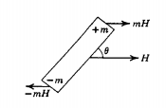

Figure 1

The magnetic dipole moment $\hat{μ}$ of an orbiting/spinning electron is related to the g-factors for the spin and orbital angular momentum, the spin angular momentum operator $\hat{S}$ and the orbital angular momentum operator $\hat{L}$ **[**Blundell**] [**Demokritov**]**:

$$\hat{μ}=μ_{B}(g_{L}\hat{L}+g_{S}\hat{S}) \left(5\right)$$

$where g_{L}=1, g_{S}=2$.0023, $μ_{B}=\frac{eℏ}{2m_{e}}$.

The magnetic field of the orbiting electron interacts with its spin to produce intrinsic spin-orbit interaction [Demokritov]. Hence the moment attains discrete values depending on the spin and orbital quantum numbers [Leuenberger]. The net magnetic moment of an atom or ion is the vector sum of the orbital and spin moments of all electrons in its outer shell. The energy levels of an electron split in a magnetic field due to Zeeman splitting and Heisenberg exchange interaction [Demokritov] [Blundell]:

$$E=-μ.B$$

$$E=-\sum_{ij}{J_{ij}S_{i}.S_{j}}+μ_{B}g_{S}\sum_{j}{S_{i}.B}$$

where $J_{ij}$ is the exchange constant between state i and j.

Two dipoles attract each other if unlike poles are close to each other. On the other hand, two dipoles repel each other if like poles are closer. Inside an unmagnetized material, the magnetic dipoles are optimally oriented hence the net torque is zero. Only a few orientations can result in a net zero torque on all the dipoles in a magnetic material. Dipoles tend to align parallel to neighboring dipoles due to positive exchange interactions so that the lowest energy state can be achieved.

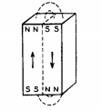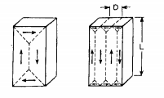

Figure 2

Atoms contain orbitals with discrete levels of energy for accommodating electrons. Electrons try to occupy the lowest energy orbitals first to minimize the energy of the system. An electron with clockwise spin can pair with an electron having anticlockwise spin. Hence, the clockwise spin cancels the effect of anticlockwise spin and no magnetic moment results [Demokritov].

An external magnetic field can cause a mechanical torque on a magnetic dipole. The moment tries to turn the dipole in the direction that decreases the overall energy of the system. Only unpaired spins contribute to the net magnetic moment. The resulting spin and orbital moments add up to produce a net Magnetization Vector Field M inside the magnetic material [Demokritov]. This field is proportional to the magnetic susceptibility of the material $χ_{m}$:

$$M=χ_{m}H ()$$

According to the Curie Weiss Law [Blundell], the susceptibility decreases rapidly when the temperature is increased beyond the Curie temperature $T_{c}$, when the ferromagnet becomes a paramagnet.

$$χ_{m}=\frac{C}{T-T_{c}} where T_{c}=\frac{Cλ}{μ_{0}}$$

According to the Landau mean-field theory for ferromagnetism [Blundell], the Magnetization is related to temperature by the relation:

$$M=±\sqrt{\frac{a_{0}(T_{c}-T)}{2b}}$$

The Spin wave Theory of Felix Bloch [Demokritov] [Blundell] states that Magnons carry quantized energy and momentum at T > 0 K. Each Magnon has spin $ℏ$ and magnetization $γℏ$. These quasiparticles are responsible for the exchange interactions inside the ferromagnet. The Bloch relation for the Magnetization is

$$M=M_{0}(1-\sqrt[\frac{3}{2}]{\frac{T}{T_{c}}})$$

The experimental results deviate from the theoretical formulas near the Curie Temperature. From experiments, it has been concluded that ferromagnetic materials have the following exponential relations for susceptibility and Magnetization near Curie temperature [Demokritov] [Blundell]:

$$χ_{m}∝\frac{1}{{\left(T-T_{c}\right)}^{γ}}$$

$$M∝{\left(T-T_{c}\right)}^{β}$$

The Magnetic Field inside a magnetic material can be represented by a flow of magnet field lines [Cividjian]. The number of lines passing through a region of space is called Magnetic Flux (equivalent to magnetic charge). Magnetic Flux Density (B) represents the number of flux lines per unit area:

$$B=μ_{0}(H+M) (7)$$

Iron, Nickel and Cobalt contain 4, 3 and 2 unpaired electrons per atom respectively [Ozgur]. Hence, the effect of Magnetization is very strong in these special elements and their alloys. Large scale cooperation between magnetic dipoles causes an enhanced Magnetic moment. Due to the high magnetic susceptibility, they are used in the production of Ferromagnetic and Ferrimagnetic materials [Ozgur].

The microscopic bound current responsible for producing magnetic dipoles cancels out inside a uniformly magnetized material. A net bound current flows at the surface of the material. If **M** is non-uniform, the bound current will be non-zero inside the material as well.

$$J_{bound}=∇×M$$

$$∇.H=-∇.M$$

The parallel alignment of magnetic dipoles causes the creation of magnetic domains [Goldman] to reduce the magnetic potential energy stored in the Magnetic Flux Lines. The Magnetic energy consists of the following:

1. Magnetostatic Energy: The energy needed to place the magnetic poles in a specific geometric configuration e.g. magnetized state [Goldman]. Magnetostatic Energy Density is proportional to the width of the magnetic strip (d) and the value of applied Magnetic Field Intensity (H). Transformers are made using insulated sheets of steel having high electrical resistance [Dinulovic] [Goldman]. Rolling of the sheets aligns the Magnetic domains and reduces the Magnetostatic Energy [Goldman]. The expression is given below
$$E∝dH^{2} (8)$$

2. Magneto-crystalline Anisotropy Energy: For crystalline structures with repeating atomic units, the domain magnetization tends to align along one direction more easily than other directions. Magneto-crystalline Anisotropy Energy is greater in hard direction as compared to the easy direction [Goldman]. It depends on the anisotropy constants ($K_{i}$) and direction cosines ($α_{i}$) which project magnetization on the different axes e.g.
$$E=K_{1}(α_{x}α_{y}+α_{y}α_{z}+α_{z}α_{x})$$

3. Magnetostrictive Energy: Magnetization and Demagnetization can cause changes in the dimensions of the magnetic materials [Goldman]. These stresses are caused by shifting of atomic planes e.g. during alignment of domains. Magnetostrictive Energy represents the elastic potential energy stored in the constricted atomic configuration. It is proportional to the magnetostriction constant ($λ$) and applied stress ($σ$).
$$E∝\frac{3}{2}λσ (10)$$

4. Domain Wall Energy: A Domain wall is a region where the Magnetization in one domain gradually changes to the direction of a neighboring domain [Goldman]. Domain Wall Energy represents the energy in the transition region. It is related to Anisotropy Constant ($K_{a}$), Curie Point ( $T_{c})$ and atomic spacing (a).

$$E∝\sqrt{\frac{K_{a}T_{c}}{a}} (11)$$

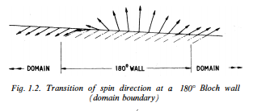

Figure 3

Naturally, the size and direction of magnetic domains [Goldman] is chosen to minimize the overall magnetic energy of the system. If an unmagnetized material is placed in an external magnetic field, the domains may have to align in a hard direction for Magnetization of the material. Work will be done to align the domains in the special configuration so that the preferable domains grow in size while the unfavorable domains shrink. This will involve displacement of atomic planes and domain boundaries. Hence the overall stored magnetic energy of the system will increase during magnetization [Goldman].

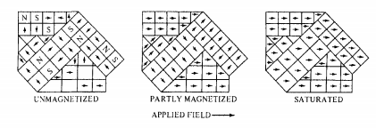

Figure 4

When a demagnetized material is placed in an increasing Magnetic Field, the domain walls will start reversible movements and rotations. The Magnetization will start to increase slowly as shown in the Figure below. This corresponds to the elastic phase with minimum magnetic susceptibility. Later on, the domain wall motions increase greatly. Large scale irreversible atomic plane displacements correspond to the partial magnetism phase in magnetization curve. During this phase, the material exhibits the highest magnetic susceptibility. Soon the majority of domains get aligned with the magnetic field. In the last phase, a large amount of energy is needed to rotate the remaining domain magnetization hence the material exhibits a saturating magnetic susceptibility. At high fields, the induction saturates at Bmax.

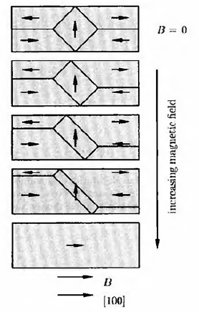

Figure 5

Figure 6: Magnetization vs. Applied Field

If the applied field of the saturated material is decreased, the magnetic domains start to reverse their direction [Goldman]. Initially, the material exhibits a small magnetic susceptibility. This resistance results because the majority of domains are aligned in the easy direction. The favorable domains had shrunk during the magnetization. Work must be done to expand the favorable domain walls in the reverse direction. As a result, demagnetization does not follow the curve of the original magnetization. When the applied field is decreased further, the magnetic susceptibility of the material starts to increase as more domains start to align in the reverse direction [Pozar].

The induction lags the applied field hence some remnant induction remains when applied field is reduced to zero. In order to demagnetize the material, some extra amount must be applied.This amount is called the coercive force. As the field keeps decreasing, the domains start aligning in the hard direction. Once all the domains have aligned, the material saturates in the reverse direction.

If the material is now magnetized again, the response will contain all the phases described earlier. The induced field will start to increase slowly, followed by a phase of large magnetic susceptibility and end by saturating.

Hysteresis [Luo] can also be experienced in a single domain particle as dictated by the Stoner-Wohlfarth model [Pozar] [Macías-Díaz].

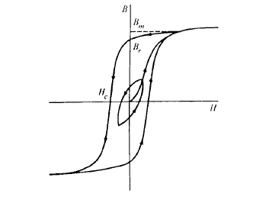

Figure 7: Hysteresis Loop

The slope of the B-H curve is called permeability [Pozar]. It is closely related to the magnetic susceptibility $χ_{m}$.

$$μ=\frac{B}{H}=μ_{0}\left(1+χ_{m}\right) (12)$$

When the material is saturated, the magnetic susceptibility becomes zero. Hence the permeability reduces to $μ_{0}$. Besides Magnetic Field Intensity, permeability is strongly dependent on chemical composition, crystal structure, stress, temperature and time after magnetization [Pozar].

## AC Losses in Magnetic Materials

After the brief introduction of the hysteresis loop [Macías-Díaz] in the last section, this section will explain the different mechanisms of AC losses [Erickson] in magnetic materials.

The cyclic magnetization of a Magnetic Material causes many energy losses [Pozar]. The atomic plane displacements and domain wall rotations cause mechanical losses in the material. Induced voltages cause circulating currents and electrical losses. At microwave frequencies, magnetic resonance and complex permeability [Pozar] [Chua] [Deng] can cause a significant increase in the losses. The various loss mechanisms [Erickson] are:

1. Hysteresis Losses: During the traversal of magnetization loop, energy is lost as heat during irreversible domain changes [Pozar] [Macías-Díaz] [Luo]. The permeability changes with position, the applied field strength, time after demagnetization (disaccommodation), frequency and temperature [Pozar] [Erickson] [Luo]. Fields inside Anisotropic media can be represented by a 3 $×$ 3 permeability/ magnetic susceptibility tensor [Pozar]:

$$\left[\begin{matrix}B_{x} \\ B_{y} \\ B_{z}\end{matrix}\right]=\left[\begin{matrix}μ_{xx} & μ_{xy} & μ_{xz} \\ μ_{yx} & μ_{yy} & μ_{yz} \\ μ_{zx} & μ_{zy} & μ_{zz}\end{matrix}\right]\left[\begin{matrix}H_{x} \\ H_{y} \\ H_{z}\end{matrix}\right] ()$$

This hysteresis loss [Luo] is equal to the area inside the DC hysteresis loop [Macías-Díaz] [Pozar]:

$$W_{H}=\int{B}dH ()$$

Hysteresis loss increases with the applied field strength and frequency [Pozar] [Erickson] [Luo]. The empirical formula for Hysteresis Loss Density [Macías-Díaz] is:

$$P_{H}∝B_{max}^{n}f ()$$

1. Eddy Current Losses: Ferromagnetic materials are semiconductors with resistivity ($ρ$) ranging from 0.1Ωm to greater than 1MΩm. The associated permittivity causes dielectric losses [Nitu]. Whenever a changing electromagnetic field is impressed induced voltages are developed in the material [Paul]. These generate circulating eddy currents in the material and produce Ohmic losses [Erickson] [Pozar].

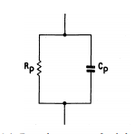

Figure 8

These losses can be reduced by using thin laminated magnetic films or magnetic grains for manufacturing. The Eddy current losses [Erickson] depend on the shape and size (d) of the material, the frequency (f), the applied field intensity ($B_{max}$) and the resistivity ($ρ$) or conductivity ($σ=\frac{1}{ρ}$) [Pozar]. The empirical formula for Eddy Current Loss Density is:

$$P_{e}∝\frac{{\left(B_{max}fd\right)}^{2}}{ρ} ()$$

The Eddy Current Losses [Erickson] can be enhanced at high frequencies due to dimensional resonance [Chua] [Cividjian]. If a dimension of the magnetic material is equal to a quarter multiple of the electromagnetic wavelength, a standing wave can develop inside it. Under this condition, the in-phase flux cancels the anti-phase flux so the observed permittivity and permeability drops to zero [Paul]. The resulting Eddy Current loss shows a peak during resonance [Pozar] [Chua]. We can represent complex permittivity and complex permeability as:

$$ε=ε_{0}(ε^{'}-j{(ε}^{''}+\frac{σ}{ω})) ()$$

$$μ=μ_{0}\left(μ^{'}-jμ^{''}\right) ()$$

The real part is responsible for the displacement current, whereas the imaginary part contributes to the conduction current. During Dimensional Resonance [Chua], the electric conductance of the magnetic material increases greatly. Hence the material acts like an electric conductor with a very low resistivity [Pozar]. Although Magnetic conduction currents do not exist, Magnetic displacement currents can flow inside a magnetic material [Cividjian]. When the real permeability drops, the magnetic displacement currents are restricted and the magnetic susceptibility falls. This causes failure of the magnetic system. The associated loss tangents are:

$$tanδ_{d}=\frac{ε^{''}}{ε^{'}} ()$$

$$tanδ_{m}=\frac{μ^{''}}{μ^{'}} ()$$

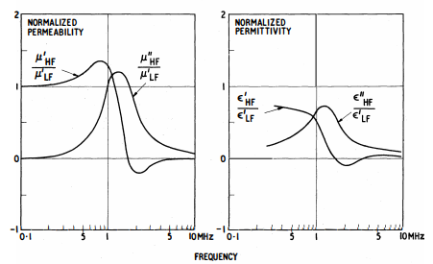

Figure 9

1. Residual Losses: Besides hysteresis loss [Macías-Díaz] [Luo] and eddy current loss, several processes can contribute to losses [Cividjian] [Erickson] when the eddy currents are negligible and the applied flux density is extremely small. These stray losses [Nnachi] are independent of the flux density but they increase with frequency [Pozar]. The associated loss tangent is $tanδ_{r}$.

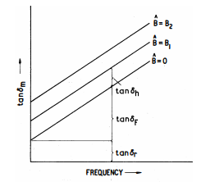

Figure 10

The total loss tangent due to hysteresis loss [Macías-Díaz] [Luo], eddy current loss and residual loss [Nnachi] [Erickson] is:

$$tanδ_{m}=tanδ_{H}+tanδ_{E}+tanδ_{r} ()$$

In conclusion, the losses due to hysteresis [Macías-Díaz] [Luo], Eddy currents, Piezomagnetism, Magnetoresistance, Magnetostriction and other residual loss mechanisms [Nnachi] [Erickson] can be expressed as heat losses across an effective resistance or conductance.

## Literature Review

This section presents a literature review of Magnetic Transmission Lines [Faria] in context of the recent research on Giant Magnetoresistance, Magnetic Capacitance, Magnetic Memory [Khitun], Spintronic [Leuenberger] and Nanomagnetic Logic Devices [Imtaar] [Holynska] [Atulasimha] [Demokritov] [Eichwald] [Guimaraes].

Faria [1-4] [Faria] presented a Time and Frequency domain theory of multi-wire magnetic transmission lines based on the matrix theory of multi-conductor electric transmission lines. For magnetic transmission lines [Faria], transverse impedance and the longitudinal admittance determine the propagation constants for the wave modes. Simulations showed that they exhibit super-luminal phase velocity and almost zero attenuation dispersion [Deng]. He also established a relationship between voltages and currents at the multi-conductor transmission line ports by employing the transmission matrix techniques. Mathematical models were developed for studying the Frequency Domain Behavior of non-uniform Magnetic Transmission Lines [Faria]. Solutions to Electromagnetic equations were presented in the form of a superposition of natural modes of propagation [Paul]. The Magnetic Transmission Line exhibited the behavior of a high pass filter, blocking all DC signals. DC signals produce the most severe transients in Electric Transmission Lines [Brignone]; which behave like a low pass filter. Moreover, he developed a model for ideal transformers using magnetic transmission line theory [Faria] [Caloz].

Antonini [Antonini] presented an in-depth analysis of meta-material transmission lines [Caloz]. The ladder network structure of the transmission line was used to obtain dominant zeros and poles. This lead to a rational form of the two port network transfer function. The rational form of the transfer functions provided an efficient time-domain macro model; which accurately captured the physics of composite meta-material transmission lines [Antonini] [Caloz]. Caloz and Itoh [11] also presented non-linear electromagnetic meta-material Transmission Lines [Caloz] focusing on their complex permittivity and permeability. They used the transmission matrix method to formulate equations for the dispersive [Deng], distributed non-linear system [Bragg]. These results are very useful in understanding the complex dispersive and radiative nature of Magnetic Transmission Lines [Faria].

Edwards and Steer [15] compared copper, ferrite meta-conductor and magnetized permalloy meta-conductor based coplanar waveguides. Magnetized ferrite layer provided some skin effect suppression compared to copper waveguide; however, permalloy provided the most uniform current profile. Some applications of Ferrite materials are high frequency phase shifters, circulators and isolators [Ozgur] [Harris] [Goldman]. Phase shifters used in test and measurement systems can be controlled using the bias magnetic field. Electronically controlled phase shifters are used in phase array antennas for steering antenna beam in space. Microwave circulators [Pozar] use ferrites to separate received and transmitted waves in radar systems [Harris] [Deng] [Ozgur]. Magnetized films also act as Radio Frequency selective limiters. Microwave Ferrite isolators are used for unidirectional transmission in plasma systems [Moryc] [Deng] [Goldman]. Their blocking capability protects precious microwave sources [Parson].

Neuber et al. [16], [17] presented gyromagnetic Non Linear Transmission Lines [Romanchenko] constructed out of nickel-zinc (NiZn), magnesium-zinc (MgZn), manganese-zinc (MnZn) and yttrium iron garnet (YIG) ferrites [Pozar] [Ozgur] [Harris] [Goldman]. Biased Anisotropic Magnetic Transmission lines [Faria] functioned as microwave sources [Parson] because of Gyromagnetic Precession [Romanchenko] [Parson]. Their performance strongly depended on Magnetic Saturation experienced at high biasing Field Strengths.

Paul [13] has presented Time domain [Sui] and frequency domain Lumped Inductive-Capacitive Coupling Circuits [Edwards] for cross talk between different Electric Transmission Line Conductors. The generator-receptor model is well suited for studying Radiated/ Conducted Emissions and Susceptibility. Such models must be developed for Magnetic Transmission Lines [Faria] as well; to study their Electromagnetic Interference and Electromagnetic Compatibility [Paul].

Paul, Whites and Nasar [Paul] have presented a step-by-step method to solve the Maxwell’s equations [Paul] in sinusoidal steady state; due to a given current distribution in a homogeneous, linear, isotropic medium. First, magnetic potential field is calculated at all desired points in space, due to the current distribution. The curl of the magnetic potential field is used to obtain the magnetic field. The Divergence of the magnetic potential field is used to obtain the scalar Electric Potential. In turn, the magnetic potential field and the gradient of the electric potential are used to derive the Electric field. The procedure is much more complicated for waveguides in inhomogeneous, anisotropic, and non-linear media [Bragg]; hence, numerical methods [Er-Ping] are suggested where a closed form solution is not possible.

Er-Ping [14], [12] and has discussed a wide range of standard time and frequency domain Computational Electromagnetics Methodologies [Er-Ping]. Time Domain Methods [Sui] include Analytical Methods, Finite Difference Methods (FDTD) [Li] [Brignone], Finite Integral Methods (FIT), Finite Volume Methods (FVTD), Fast Multipole Method (FMM), Partial Element Equivalent Circuit Method (PEEC), Transmission Line Method (TLM) [Li] etc. Frequency Domain Methods include Method of Moments (MoM), Finite Element Method (FEM), Geometric Theory of Diffraction (GTD), Physical Theory of Diffraction (PTD) etc. He compared Finite Difference Methods, Method of Moments and Finite Element Method, in respect of Principle, geometry materials, Meshing, Matrix Equation and Boundary Treatment. He gave a list of commercially available simulators along with some common applications like high-speed electronics [Pozar], photonics [Chua] [Demokritov], microwave circuits [Deng], integrated circuits and Antennas. The Finite Difference Method can obtain response over a broad band of frequencies for many non-linear [Bragg] and inhomogeneous media without using matrix equations [Brignone] [Li]. This method is well suited for simulation of dispersive [Deng], non-uniform Magnetic Transmission Lines [Faria].

## Outline

This chapter discussed the nature of Magnetic materials and the transmission of magnetic information using magnetic dipoles and Bulk Magnetization. The AC losses [Erickson] of magnetic materials include hysteresis losses [Macías-Díaz] [Luo], eddy current losses and residual losses [Nnachi] due to complex permeability and permittivity. A literature review of Magnetic Transmission Lines [Faria] in context of recent research on Ferromagnetic Modeling and Simulation [Edwards].

Chapter 2 will discuss the propagation of electromagnetic waves in anisotropic, inhomogeneous, dispersive [Luo] [Deng] Ferromagnetic materials as dictated by the Maxwell’s Laws [Paul].

Chapter 3 presents three different models for Magnetic Elements: Reluctance Model, Permeance-Capacitance Model [Luo] [Hamill] [Allmeling] [Anderson] and the Magnetic Transmission Line Model [Faria].

Chapter 4 is dedicated to computational electrodynamics [Er-Ping] i.e. the low frequency and high frequency methods for solving Maxwell’s equations [Paul]. An overview of Finite Difference Time Domain method [Li] [Sui] [Brignone] is presented which solves partial differential equation using leapfrog method. The MEEP [Oskooi] simulator uses this method for evolving electromagnetic fields in anisotropic, inhomogeneous, dispersive [Deng] Ferromagnetic materials.

# Wave Propagation in Magnetic Materials

This chapter will discuss the propagation of electromagnetic waves in anisotropic, inhomogeneous, dispersive [Deng] Ferromagnetic materials as dictated by the Maxwell’s equations [Paul].

## Plane Wave Propagation

Ideal Magnetic Transmission Lines [Faria] can be modeled as linear, isotropic, homogeneous media.

The corresponding Maxwell’s equations [Paul] are:

1. Ampere’s Law [Paul]
$$∇×H=σ_{e}E+\frac{dD}{dt} ()$$

2. Faraday’s Law [Paul]

$$∇×E=-μ_{0}\frac{dB}{dt} ()$$

Subject to the boundary conditions [Paul]:

1. The perpendicular components of **B** and **D** follow these conditions:
$$B_{⏊1}=B_{⏊2} and D_{⏊1}-D_{⏊2}=ρ_{s}$$

2. The parallel components of **H** and **E** follow these conditions:

$$H_{∥1}-H_{∥2}=J_{s} and E_{∥1}=E_{∥2}$$

The solution is given by the Helmholtz Equations [Paul]:

$$∇×∇×E=-\frac{∂(∇×B)}{∂t}=μσ_{e}\frac{∂E}{∂t}+με\frac{∂^{2}E}{∂t^{2}} ()$$

$$∇×∇×H=σ_{e}(∇×E)+\frac{∂(∇×D)}{∂t}=μσ_{e}\frac{∂H}{∂t}+με\frac{∂^{2}H}{∂t^{2}} ()$$

For sinusoidal steady state:

$$∇^{2}E=γ^{2}E ()$$

$$∇^{2}H=γ^{2}H ()$$

$$γ=\sqrt{jωμσ_{e}-ω^{2}με}=α+jβ ()$$

The propagation constant ($γ$) dictates the wave propagation in the medium. Considering plane wave propagation in the z direction, the solution is:

$$E_{x}\left(z\right)=E_{m}^{+}e^{-αz-jβz+jθ^{+}}+E_{m}^{-}e^{αz+jβz+jθ^{-}} ()$$

$$H_{y}\left(z\right)=\frac{E_{m}^{+}}{η}e^{-αz-jβz+jθ^{+}-jθ_{η}}-\frac{E_{m}^{-}}{η}e^{αz+jβz+jθ^{-}-jθ_{η}} ()$$

The attenuation constant ($α$) represents the loss or attenuation of fields. The skin depth ($δ$) is defined as the penetration measured from the surface at which the amplitude reduces by a factor of 1/e:

$$δ=\frac{1}{α}=\sqrt{\frac{2}{ωμσ_{e}}} ()$$

The phase constant $β$ dictates the phase velocity (u) and wavelength (𝜆):

$$u=\frac{ω}{β} ()$$

$$λ=\frac{2π}{β} ()$$

The ratio of matching Electric Field Intensity $E^{+}/E^{-}$ and Magnetic Field Intensity $H^{+}/H^{-}$ determines the intrinsic impedance of the material:

$$η=\frac{jωμ}{γ}=\sqrt{\frac{jωμ}{σ_{e}+jωε}} ()$$

For lossless magnetic materials with very small $σ_{e}$,

$$β≈β_{o}\sqrt{μ_{r}ε_{r}} ()$$

$$u≈\frac{u_{o}}{\sqrt{μ_{r}ε_{r}}} ()$$

$$λ≈\frac{λ_{o}}{\sqrt{μ_{r}ε_{r}}} ()$$

$$η≈η_{0}\sqrt{\frac{μ_{r}}{ε_{r}}} ()$$

where $β_{o}$, $u_{o}$, $λ_{o}$ and $η_{0}$ represent the free space phase constant, phase velocity wavelength, intrinsic impedance respectively.

## Power Flow Analysis

The power flow density of an electromagnetic wave is given by the Poynting vector **S**. It has the units of W/m2. The Poynting flux is indicative of the amount of power flowing across a surface:

$$\oint{S.\hat{n} dS}=\int{\left(E×H\right)dS} ()$$

$$=∇.\left(E×H\right) ()$$

The expression can be expanded using the following formula:

$$∇.\left(E×H\right)=-E.\left(∇×H\right)+H.\left(∇×E\right) ()$$

$$=-E.\left(J+\frac{∂D}{∂t}\right)+H.\left(-\frac{∂B}{∂t}\right) ()$$

The flow of Poynting flux can be separated into the Ohmic Power dissipation, Electric Power flow and Magnetic Power flow:

$$-\oint{SdS}=\frac{1}{2}\int{E.J dV}+\int{E.\frac{∂D}{∂t} dV}+\int{H.\frac{∂B}{∂t} dV} ()$$

From these expressions, it is clear that the Electric Energy and Magnetic Energy of a system is:

$$W_{e}=\int{D.E dV} ()$$

$$W_{m}=\int{B.H dV} ()$$

The average power transported per unit area is the Intensity of the Electromagnetic Wave:

$$I=<S> ()$$

Electromagnetic Waves also carry momentum and the momentum density stored in the fields is

$$g=\frac{1}{c^{2}}S ()$$

The Momentum transferred to a surface results in a radiation pressure

$$P=\frac{F}{A}=\frac{1}{A}\frac{∆p}{∆t}=\frac{1}{A}\frac{<g>A c ∆t}{∆t}=<g>A c ()$$

# Magnetic Circuit Modeling

In this chapter, three different Magnetic circuit models will be presented: The Reluctance Model, The Permeance-Capacitance Model [Luo] [Hamill] [Allmeling] [Anderson] and The Magnetic Transmission Line Model [Faria]. It is understood that magnetic monopoles do not exist and Magnetic conduction current cannot flow. Any reference to the flow of Magnetic current is meant to indicate the flow of Magnetic Displacement Current i.e. the rate of change of Magnetic Flux.

The Reluctance Model is the oldest and most popular model, even though it is not a power invariant model [González]. It only has one component called the Magnetic Reluctance which resists the flow of Magnetic Flux.

The Permeance-Capacitance Model [Luo] [Hamill] [González] [Allmeling] [Anderson] overcomes the weaknesses of the Reluctance Model by considering the rate of change of Magnetic Flux as the Magnetic Current. It is a power invariant model [González] because it correctly encompasses the transformation of Magnetic and Electric Energy [Hamill]. This model has the shortcoming that it does not incorporate Electric Energy Storage and Electromagnetic losses in a Magnetic material [Erickson].

The Magnetic Transmission Line [Faria] model improves the Permeance-Capacitance Model [Luo] [Hamill] [Allmeling] [Anderson] [González] by including a component for Electric Energy Storage and a component for magnetization, polarization and conduction losses [Erickson].

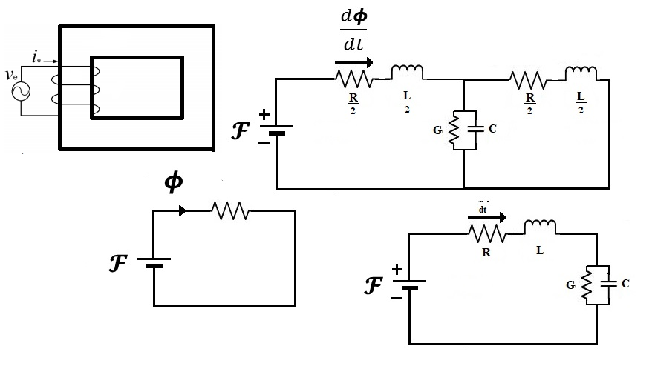

Figure 11

## Reluctance Model

This section

H. A. Rowland’s Law (1873) [Paul] is the counterpart of G. Ohm’s Law (1827) for Magnetic circuits. Complex Reluctance Model defines Magnetic reluctance as the ratio of sinusoidal Magnetomotive Force and sinusoidal Magnetic Flux.

$$R_{m}=\frac{F_{m}}{ϕ_{m}}=\frac{\oint{H.dl}}{\int{B.dS}}=|R_{m}|e^{j∅} ()$$

Lossy Complex Magnetic Reluctance is non-linear and varies with the magnetic field. It resists both Magnetic flux and changes in Magnetic flux.

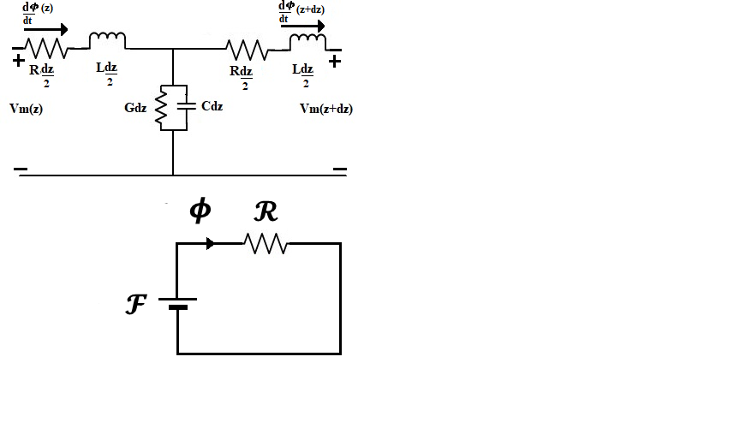

Figure 12

In 1969, R. W. Buntenbach proved that the Reluctance model [Paul] is not power invariant [González]. Reluctance Power Loss cannot be calculated using Joule Heating Law (1842) analogy due to dimensional inconsistency:

$$[P_{e}]=\left[I_{e}^{2}\right]\left[R_{e}\right]=Ampere.Volt ()$$

$$but$$

$${[P}_{m}]≠\left[ϕ_{m}^{2}\right]\left[|R_{m}|\right]=Volt.Second.Ampere ()$$

Hence this is not an accurate model for Power and Energy Flow.

## Application

This section presents the reluctance model for a Compounded DC Generator with both a series and a shunt field winding. The series field inductance $L_{S}$ has $N_{SE}$ turns. The series field winding resistance is represented by $R_{S}$. The shunt field winding inductance $L_{F}$ has $N_{F}$ turns. The shunt field winding resistance is represented by $R_{F}$. The armature winding resistance is represented by $R_{A}$.

$$V_{T}=E_{A}-I_{A}(R_{A}+R_{S})$$

$$E_{A}=kϕω_{m}$$

$$I_{L}+I_{F}=I_{A}$$

$$I_{F}=\frac{V_{T}}{R_{F}}$$

$$F_{net}=F_{F}±F_{SE}-F_{AR}$$

$$N_{F}I_{F}^{*}=N_{F}I_{F}±N_{SE}I_{A}-F_{AR}$$

$$P_{output}=V_{T}I_{L}$$

$$P_{input}=τ_{ind}ω_{m}$$

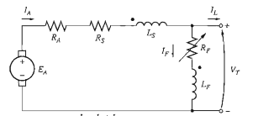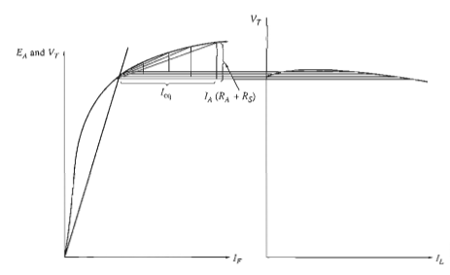

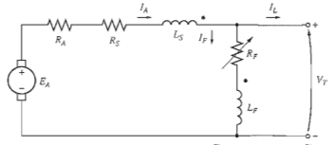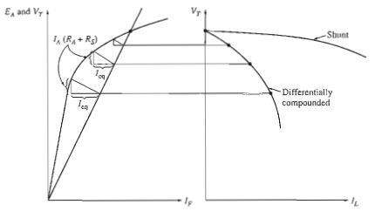

The Reluctance Model preserves the integrity of the machine’s geometry. It decouples the electrical system from the magnetic system. The magnetic paths in the core are represented using reluctance elements.

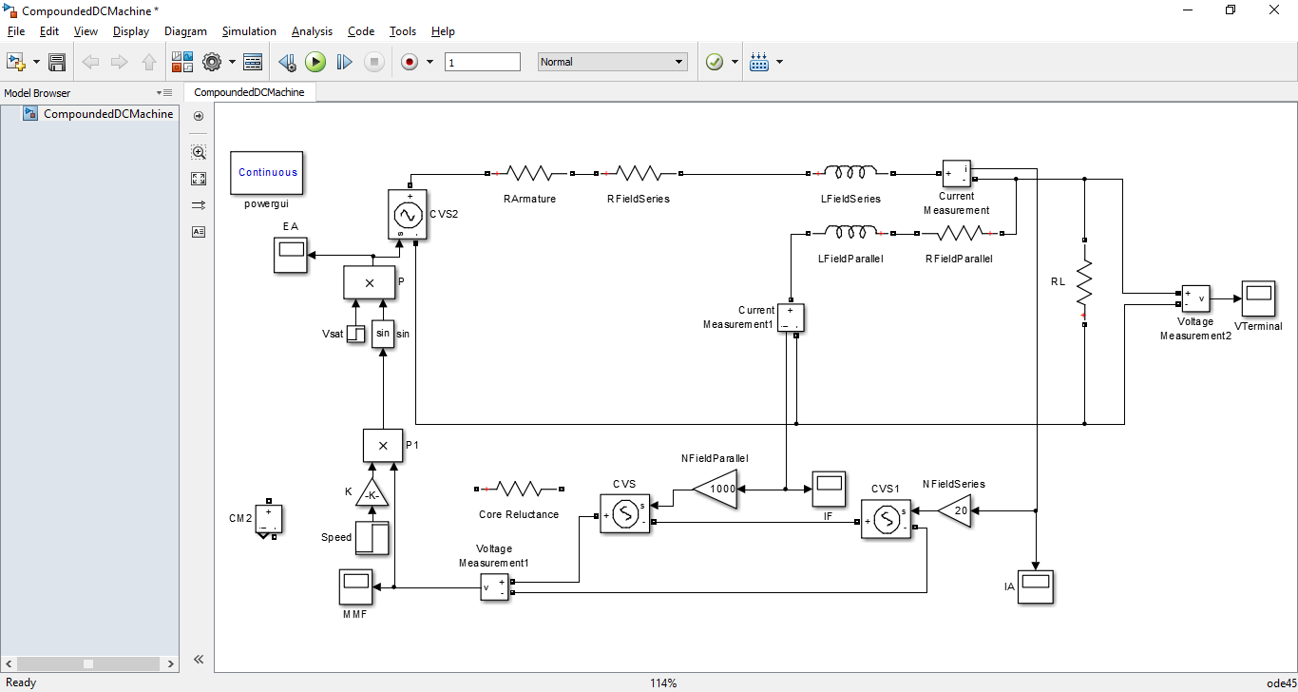

RA=0.19 Ω, RS=0.02 Ω, RF=20-50Ω, NF=1000 turns, NS=20 turns, nm=1800 rpm

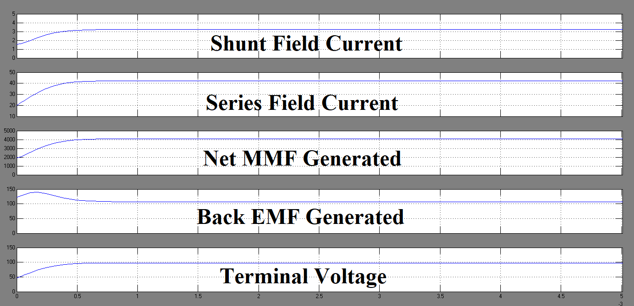

## Permeance-Capacitance Model

This section

B. Tellegen’s Gyrator theory (1948) [Hamill] [Anderson] [González] can describe power invariant transformation of magnetic and electric quantities. The dual effort and flow quantities are related by the gyration constant (N). R. W. Buntenbach proposed Power Invariant Permeance-Capacitance Model (1969) [Luo] [Hamill] [González] [Allmeling] [Anderson] to replace Reluctance Model.

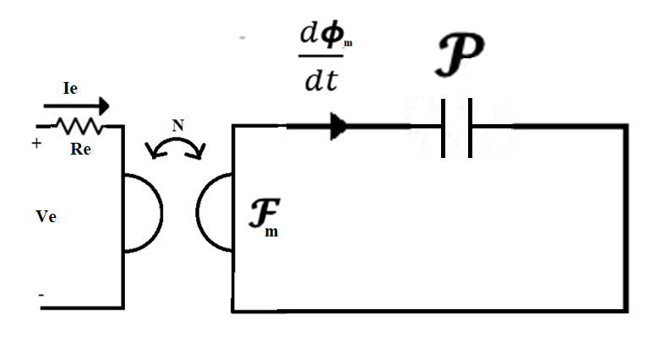

Figure 13

Magnetic Displacement Current is the rate of change of Magnetic Flux which results from the polarization of Magnetic Dipoles. For a magnetic core, the magnetic current and Magnetomotive Force are given by:

$$I_{m,disp}=\frac{dϕ_{m}}{dt}=-\frac{1}{N}V_{e} [Volt] ()$$

and

$$V_{m}=F_{m}=NI_{e} [Ampere] ()$$

Magnetic Permeance [Luo] [Hamill] [Allmeling] [Anderson] is defined as:

$$P_{m}=\frac{ϕ_{m}}{F_{m}}=\frac{\int{B.dS}}{\oint{H.dl}}=μ\frac{A}{l} [Henry] ()$$

This represents an equivalent magnetic capacitor which stores magnetic charge (magnetic flux).

M. Faraday’s Law (1831): Electric Voltage is responsible for producing Magnetic Current (rate of change of magnetic flux).

$$V_{e}=-N\frac{dϕ_{m}}{dt} ()$$

$$\oint{E.dl}=-\frac{d}{dt}\int{B.dS} ()$$

$$=-μ_{0}\frac{d}{dt}\int{H.dS}-μ_{0}\frac{d}{dt}\int{M.dS} ()$$

A. Ampere’s Law (1861) [Paul]: Magnetic Voltage is responsible for producing Electric Conduction Current [Paul].

$$F_{m}=NI_{e} ()$$

## Application

This section presents a Permeance-Capacitance Model [Luo] [Hamill] [Allmeling] [Anderson] for a multiple output Isolated Buck Converter.

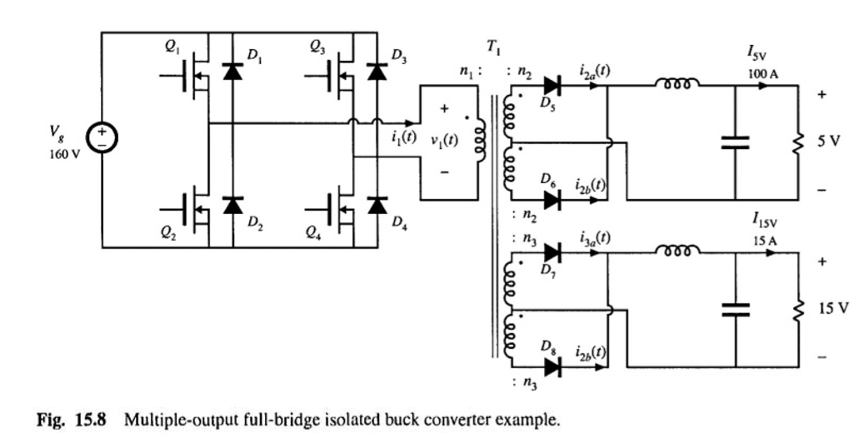

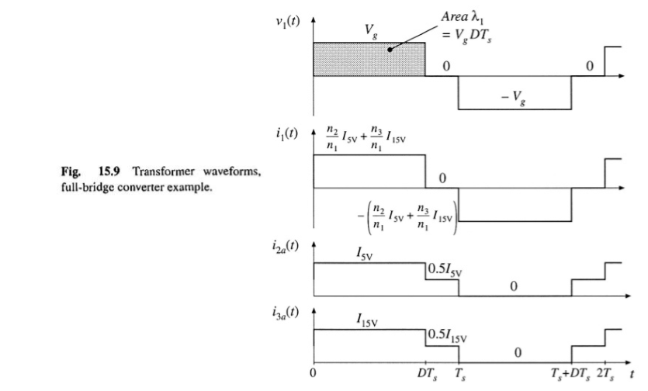

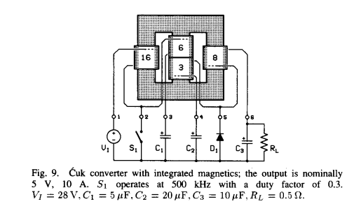

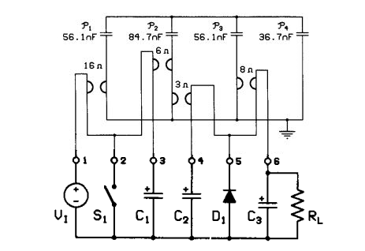

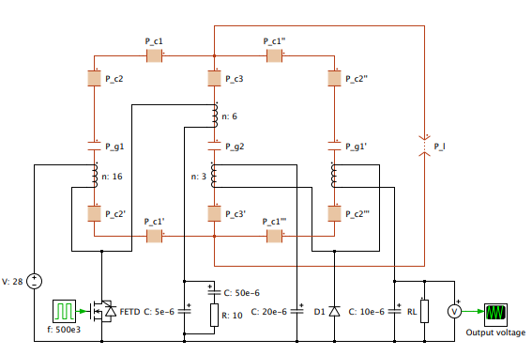

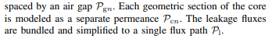

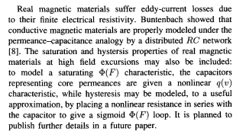

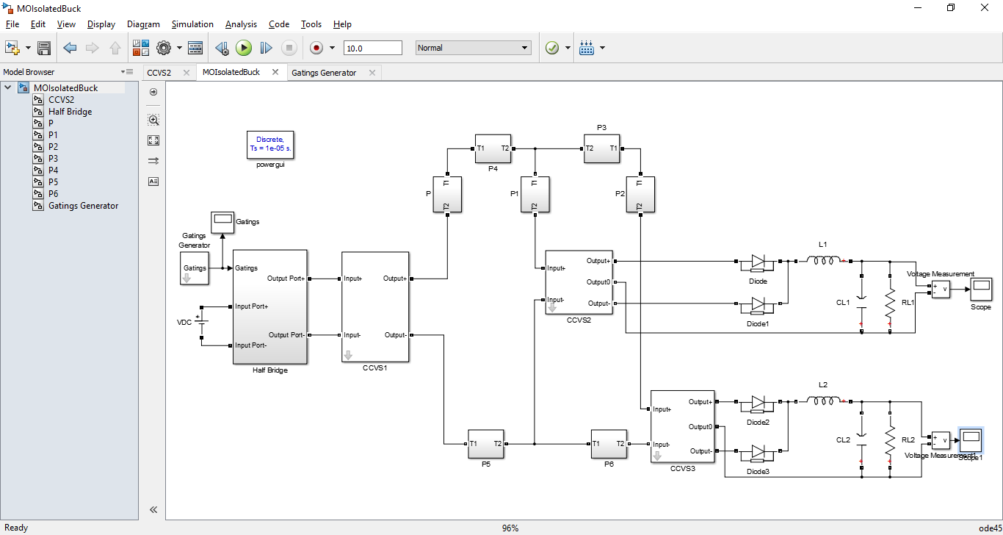

## Magnetic Transmission Line Model

This section

J. A. B. Faria and M.P. Pires presented Magnetic Transmission Line Model [Faria] (2012) based on Electric Transmission Line Model in terms of per unit length transverse Impedance and per unit length Longitudinal Admittance.

The propagation of electromagnetic waves is governed by the Maxwell’s Equations [Paul]:

$$\oint{H.dl}=\oint{J_{e} dS}+\frac{d}{dt}\int{D dS}=\oint{J_{e} dS}-ε_{0}\frac{d}{dt}\int{E.dS}-ε_{0}\frac{d}{dt}\int{E.dS} ()$$

$$\oint{E.dl}=-\frac{d}{dt}\int{B.dS}=-μ_{0}\frac{d}{dt}\int{H.dS}-μ_{0}\frac{d}{dt}\int{M.dS} ()$$

$$\oint{B.dS}=0 ()$$

$$\oint{D.dS}=\iiint{ρ_{e}}dV ()$$

Analogous to the scalar Electric Potential, scalar magnetic potential $V_{m}$ can be defined as

$$V_{m}=\int_{a}^{b}{H.dl} ()$$

$$H=∇V_{m} ()$$

The Magnetic Displacement Current $I_{m}$ is defined as the rate of change of magnetic flux $Φ_{m}$:

$$\oint{E.dl}=-\int{\frac{dB}{dt}.dS}=-\oint{J_{m} dS}=-\frac{dΦ_{m}}{dt}=I_{m} ()$$

$$∇×E=-J_{m} ()$$

The per unit length transverse magnetic inductance $L_{T}$ represents a magnetic Energy storage element. It is defined in terms of per unit length Magnetic charge $Φ_{m}$ and scalar magnetic voltage $V_{m}$ as

$$Φ_{m}=L_{T}V_{m} ()$$

The per unit length longitudinal capacitance $C_{L}$ represents an Electric Energy storage element. It is defined in terms of electric displacement flux $Ψ_{e}$ and magnetic displacement current $I_{m}$ as $$Ψ_{e}=C_{L}I_{m} ()$$

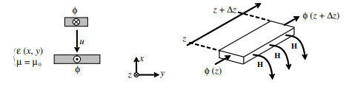

Figure 14

Assuming TEM-guided propagation in z-direction ($E_{y}=E_{z}=H_{x}=H_{z}=0, ρ_{e}=J_{e}=0$), the relation between the magnetic voltage and magnetic current for a homogeneous magnetic transmission line [Faria] is derived by substituting the previous expressions in the Maxwell’s Equations [Paul].

$$\frac{d}{dz}\int{E_{x}dx}=-μ\frac{d}{dt}\int{H_{y}dx} ()$$

$$\frac{d}{dz}\int{H_{y}dy}=-ε\frac{d}{dt}\int{E_{x}dy} ()$$

The resulting Transmission Line Equations are

$$\frac{dI_{m}}{dz}=-L_{T}\frac{dV_{m}}{dt} ()$$

$$\frac{dV_{m}}{dz}=-C_{L}\frac{dI_{m}}{dt} ()$$

A forward travelling and a backward travelling wave can simultaneously exist on the transmission line. The solution for the Magnetic voltage and Magnetic current is

$$V_{m}\left(z\right)=V_{m}^{+}e^{-jβz+jθ^{+}}+V_{m}^{-}e^{jβz+jθ^{-}} ()$$

$$I_{m}\left(z\right)=\frac{V_{m}^{+}}{Z_{o}}e^{-jβz+jθ^{+}-jθ_{z}}-\frac{V_{m}^{-}}{Z_{o}}e^{jβz+jθ^{-}-jθ_{z}} ()$$

The propagation constant is defined as

$$β=\sqrt{L_{T}C_{L}} ()$$

The characteristic impedance is the ratio of Magnetic Current to the Magnetic Voltage. It is calculated as

$$Z_{m}=\frac{I_{m}(z)}{V_{m}(z)}=\sqrt{\frac{L_{T}}{C_{L}}} ()$$

The average power flow in the Magnetic Transmission Line [Faria] can be represented in terms of three distinct components: the average power in the forward travelling wave, the average power in the backward travelling wave and the dissipated power.

$$P_{av}\left(z\right)=\frac{1}{2}Re\left(V\left(z\right)I^{*}\left(z\right)\right) ()$$

$$P_{av}\left(z\right)=\frac{1}{2}Re(\left(V_{m}^{+}e^{-αz-jβz+jθ^{+}}+V_{m}^{-}e^{αz+jβz+jθ^{-}}\right)\left(\frac{V_{m}^{+}}{Z_{o}}e^{-αz+jβz-jθ^{+}+jθ_{z}}-\frac{V_{m}^{-}}{Z_{o}}e^{αz-jβz-jθ^{-}+jθ_{z}}\right))()$$

$$P_{av}\left(z\right)=P_{av}^{+}\left(z\right)+P_{av}^{-}\left(z\right)+P_{loss}(z) ()$$

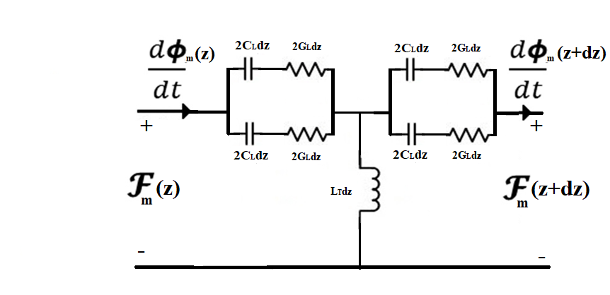

Figure 15

In a non-ideal magnetic transmission line [Faria], magnetic voltage drop can be accounted by including magnetic reluctance/ conductance. It represents all the magnetization, polarization and conduction losses [Erickson] due to electric conductivity, complex permittivity and complex permeability. Magnetic Inductance and Magnetic Capacitance are energy storage elements in this model.

$$G_{L}=\frac{R_{m}}{jω}=\frac{V_{m}}{I_{m}}=\frac{\int{H.dl}}{\oint{E.dl}} [Ohm] ()$$

$$L_{T}=\frac{ϕ_{m}}{V_{m}}=\frac{\int{B.dS}}{\int{H.dl}} [Henry] ()$$

$$C_{L}=\frac{ϕ_{e}}{I_{m}}=\frac{\int{D.dS}}{\oint{E.dl}} [Farad] ()$$

Energy is dissipated in Magnetic Conductance:

$$P_{loss}=I_{m}^{2}G_{m} ()$$

Electrical Energy is stored in Magnetic Capacitance; and Magnetic Energy is stored in Magnetic Inductance.

$$W_{e}=\frac{1}{2}{C_{m}V}_{m}^{2}=\frac{1}{2}\int{B.H dV} ()$$

$$W_{m}=\frac{1}{2}{L_{m}I}_{m}^{2}=\frac{1}{2}\int{D.E dV} ()$$

The resulting Magnetic Transmission Line Equations [Faria] are:

$$\frac{dI_{m}}{dz}=-L_{T}\frac{dV_{m}}{dt} ()$$

$$\frac{dV_{m}}{dz}=-G_{L}I_{m}-C_{L}\frac{dI_{m}}{dt} ()$$

$$\frac{d^{2}V_{m}}{dz^{2}}=L_{T}C_{L}\frac{d^{2}V_{m}}{dt^{2}}+L_{T}G_{L}\frac{dV_{m}}{dt} ()$$

$$\frac{d^{2}I_{m}}{dz^{2}}=L_{T}G_{L}\frac{d^{2}I_{m}}{dt^{2}}+L_{T}C_{L}\frac{dI_{m}}{dt} ()$$

Assuming sinusoidal steady state, the equations can be expressed in terms of phasor quantities as follows:

$$\frac{d^{2}V_{m}}{dz^{2}}=-ω^{2}L_{T}C_{L}V_{m}+jωL_{T}G_{L}V_{m}=(-ω^{2}L_{T}C_{L}+jωL_{T}G_{L})V_{m} ()$$

$$\frac{d^{2}I_{m}}{dz^{2}}=-ω^{2}L_{T}G_{L}I_{m}+jωL_{T}C_{L}I_{m}=(-ω^{2}L_{T}G_{L}+jωL_{T}C_{L})I_{m} ()$$

The Magnetic Transmission Line Equations [Faria] can be solved just like Electric Transmission Line Equations. The solutions are compared in the table below.

|  |  |
| --- | --- |
| Electric Transmission Line | Magnetic Transmission Line |
| $$\frac{dI_{e}}{dz}=-G_{T}V_{e}-C_{T}\frac{dV_{e}}{dt}$$ $$\frac{dV_{e}}{dz}=-R_{L}I_{e}-L_{L}\frac{dI_{e}}{dt}$$ | $$\frac{dI_{m}}{dz}=-L_{T}\frac{dV_{m}}{dt}$$ $$\frac{dV_{m}}{dz}=-G_{L}I_{m}-C_{L}\frac{dI_{m}}{dt}$$ |
| $$\frac{d^{2}I_{e}}{dz^{2}}=L_{L}C_{T}\frac{d^{2}I_{e}}{dt^{2}}+\left(L_{L}G_{T}+R_{L}C_{T}\right)\frac{dI_{e}}{dt}+R_{L}G_{T}I_{e}$$ $$\frac{d^{2}V_{e}}{dz^{2}}=L_{L}C_{T}\frac{d^{2}V_{e}}{dt^{2}}+\left(L_{L}G_{T}+R_{L}C_{T}\right)\frac{dV_{e}}{dt}+R_{L}G_{T}V_{e}$$ | $$\frac{d^{2}I_{m}}{dz^{2}}=L_{T}G_{L}\frac{d^{2}I_{m}}{dt^{2}}+L_{T}C_{L}\frac{dI_{m}}{dt}$$ $$\frac{d^{2}V_{m}}{dz^{2}}=L_{T}C_{L}\frac{d^{2}V_{m}}{dt^{2}}+L_{T}G_{L}\frac{dV_{m}}{dt}$$ |
| $$V_{e}\left(z\right)={V_{e}}_{i}(0)e^{-γz}+{V_{e}}_{r}(0)e^{+γz}$$ $$I_{e}\left(z\right)={I_{e}}_{i}\left(0\right)e^{-γz}-{I_{e}}_{r}(0)e^{+γz}$$ | $$V_{m}\left(z\right)={V_{m}}_{i}(0)e^{-γz}+{V_{m}}_{r}(0)e^{+γz}$$ $$I_{m}\left(z\right)={I_{m}}_{i}\left(0\right)e^{-γz}-{I_{m}}_{r}(0)e^{+γz}$$ |
| $$γ=\sqrt{\left(R_{e}+jωL_{e}\right)\left(G_{e}+jωC_{e}\right)}$$ $$γ=\sqrt{\left(ρ+jωμ\right)\left(σ+jωε\right)}$$ $$γ=α+jβ$$ | $$γ=\sqrt{\left(jωL_{m}\right)\left(G_{m}+jωC_{m}\right)}$$ $$γ=\sqrt{\left(jωμ\right)\left(σ+jωε\right)}$$ $$γ=α+jβ$$ |
| $$Z_{e}=\frac{V_{e}(z)}{I_{e}(z)}=\sqrt{\frac{R_{e}+jωL_{e}}{G_{e}+jωC_{e}}}$$ | $$Z_{m}=\frac{I_{m}(z)}{V_{m}(z)}=\sqrt{\frac{jωL_{m}}{G_{m}+jωC_{m}}}$$ |

For Transmission Lines of similar geometry, the Transmission Line parameters / matrices are closely related:

$$L_{T}L_{L}=μ_{0}^{2} ()$$

$$L_{T}C_{L}=μ_{0}ε ()$$

$$ε_{0}L_{T}=μ_{0}C_{T} ()$$

$$C_{T}C_{L}=ε_{0}ε ()$$

Magnetic cores are often manufactured using layers of laminated magnetic sheets to prevent the flow of Eddy Currents. In such materials, magnetic flux from one transmission line can link with a neighboring magnetic transmission line [Faria] and disturb the information [Er-Ping]. The Magnetic Transmission Line Model [Faria] can be extended to the generator-receptor Magnetic Transmission Line model [Faria]. This is well suited for studying Electromagnetic Coupling of Magnetic Transmission Lines [Faria] which are in close proximity.

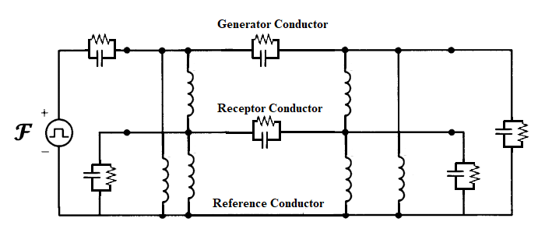

Figure 16

## Application

This section

Permanent Magnet Linear Alternator Model

## Summary

|  |  |  |  |
| --- | --- | --- | --- |
|  | **Reluctance Model** | **Permeance-Capacitance Model** | **Transmission Line Model** |
| **Conserved Quantity** | ? | Magnetic Flux  [Volt-Second] | Magnetic Flux  [Volt-Second] |
| **Flow Variable** | Magnetic Flux  [Volt-Second] | Rate of change of Magnetic Flux [Volt] | Rate of change of Magnetic Flux [Volt] |
| **Effort Variable** | Magnetomotive Force [Ampere] | Magnetomotive Force [Ampere] | Magnetomotive Force  [Ampere] |
| **Energy Dissipation Element** | Magnetic Reluctance [${Henry}^{-1}$] | ? | Magnetic Conductance  [Ohm] |
| **Electrical Energy Storage Element** | ? | ? | Magnetic Capacitance  [Farad] |
| **Magnetic Energy Storage Element** | ? | Magnetic Permeance  [Henry] | Magnetic Inductance  [Henry] |

# Computational Electromagnetics

This section discusses the different time domain [Sui] and frequency domain methods for solving Maxwell’s Equations [Paul] [Er-Ping].

## Methods for solving Maxwell’s Equations

The Maxwell’s Equations [Paul] can be solved in time domain [Sui] and frequency domain by solving Partial Differential Equations or Integral Equations.

## Time Domain Methods

1. Finite Difference Time Domain Method (FDTD): K. S. Yee’s Method (1966) is a differential numerical modeling technique for computational electrodynamics [Sui] [Er-Ping] [Li]. J. C. Maxwell’s Equations (1861) [Paul] are discretized using central difference approximations to the space and time partial derivatives. For example,

$$∇×E=-\frac{dB}{dt} ()$$

$$∇×E=\left(\frac{∆E_{z}}{∆y}-\frac{∆E_{y}}{∆z}\right)a_{x}+\left(\frac{∆E_{x}}{∆z}-\frac{∆E_{z}}{∆x}\right)a_{y}+\left(\frac{∆E_{y}}{∆x}-\frac{∆E_{x}}{∆y}\right)a_{z} ()$$

$$\frac{∆E_{y}}{∆z}-\frac{∆E_{z}}{∆y}=μ\frac{∆H_{x}}{∆t} ()$$

$$\frac{∆E_{z}}{∆x}-\frac{∆E_{x}}{∆z}=μ\frac{∆H_{y}}{∆t} ()$$

$$\frac{∆E_{x}}{∆y}-\frac{∆E_{y}}{∆x}=μ\frac{∆H_{z}}{∆t} ()$$

$$∇×H=σ_{e}E+\frac{dD}{dt} ()$$

$$∇×H=\left(\frac{∆H_{z}}{∆y}-\frac{∆H_{y}}{∆z}\right)a_{x}+\left(\frac{∆H_{x}}{∆z}-\frac{∆H_{z}}{∆x}\right)a_{y}+\left(\frac{∆H_{y}}{∆x}-\frac{∆H_{x}}{∆y}\right)a_{z} ()$$

$$\frac{∆H_{z}}{∆y}-\frac{∆H_{y}}{∆z}=σ_{e}E_{x}+ε\frac{∆E_{x}}{∆t} ()$$

$$\frac{∆H_{x}}{∆z}-\frac{∆H_{z}}{∆x}=σ_{e}E_{y}+ε\frac{∆E_{y}}{∆t} ()$$

$$\frac{∆H_{y}}{∆x}-\frac{∆H_{x}}{∆y}=σ_{e}E_{z}+ε\frac{∆E_{z}}{∆t} ()$$

Finite Difference Time Domain Method [Brignone] discretizes space into a grid of small elements called Yee Lattice (1966) [Li]. Each element can have a different conductivity, permittivity and permeability [Li] [Sui]. The different field components at a grid location are stored in the edges and faces of a cubic element. They are evolved in discrete time steps $t_{n}=n∆t$.

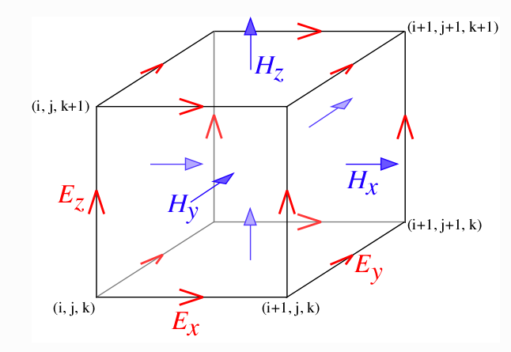

Figure 17

$$\left(\frac{E_{y}\left|\begin{matrix}n \\ i,j,k+\frac{1}{2}\end{matrix}\right.-E_{y}\left|\begin{matrix}n \\ i,j,k-\frac{1}{2}\end{matrix}\right.}{∆z}\right)-\left(\frac{E_{z}\left|\begin{matrix}n \\ i,j+\frac{1}{2},k\end{matrix}\right.-E_{z}\left|\begin{matrix}n \\ i,j-\frac{1}{2},k\end{matrix}\right.}{∆y}\right)=μ_{i,j,k}\left(\frac{H_{x}\left|\begin{matrix}n+\frac{1}{2} \\ i,j,k\end{matrix}\right.-H_{x}\left|\begin{matrix}n-\frac{1}{2} \\ i,j,k\end{matrix}\right.}{∆t}\right)()$$

$$\left(\frac{E_{z}\left|\begin{matrix}n \\ i+\frac{1}{2},j,k\end{matrix}\right.-E_{z}\left|\begin{matrix}n \\ i-\frac{1}{2},j,k\end{matrix}\right.}{∆x}\right)-\left(\frac{E_{x}\left|\begin{matrix}n \\ i,j,k+\frac{1}{2}\end{matrix}\right.-E_{x}\left|\begin{matrix}n \\ i,j,k-\frac{1}{2}\end{matrix}\right.}{∆z}\right)=μ_{i,j,k}\left(\frac{H_{y}\left|\begin{matrix}n+\frac{1}{2} \\ i,j,k\end{matrix}\right.-H_{y}\left|\begin{matrix}n-\frac{1}{2} \\ i,j,k\end{matrix}\right.}{∆t}\right)()$$

$$\left(\frac{E_{x}\left|\begin{matrix}n \\ i,j+\frac{1}{2},k\end{matrix}\right.-E_{x}\left|\begin{matrix}n \\ i,j-\frac{1}{2},k\end{matrix}\right.}{∆y}\right)-\left(\frac{E_{y}\left|\begin{matrix}n \\ i+\frac{1}{2},j,k\end{matrix}\right.-E_{y}\left|\begin{matrix}n \\ i-\frac{1}{2},j,k\end{matrix}\right.}{∆x}\right)=μ_{i,j,k}\left(\frac{H_{z}\left|\begin{matrix}n+\frac{1}{2} \\ i,j,k\end{matrix}\right.-H_{z}\left|\begin{matrix}n-\frac{1}{2} \\ i,j,k\end{matrix}\right.}{∆t}\right)()$$

$$\left(\frac{H_{z}\left|\begin{matrix}n \\ i,j+\frac{1}{2},k\end{matrix}\right.-H_{z}\left|\begin{matrix}n \\ i,j-\frac{1}{2},k\end{matrix}\right.}{∆y}\right)-\left(\frac{H_{y}\left|\begin{matrix}n \\ i,j,k+\frac{1}{2}\end{matrix}\right.-H_{y}\left|\begin{matrix}n \\ i,j,k-\frac{1}{2}\end{matrix}\right.}{∆z}\right)=σ_{e}\left|\begin{matrix}n \\ i,j,k\end{matrix}\right.(E_{x}\left|\begin{matrix}n \\ i,j,k\end{matrix}\right.)+ε_{i,j,k}\left(\frac{E_{x}\left|\begin{matrix}n+\frac{1}{2} \\ i,j,k\end{matrix}\right.-E_{x}\left|\begin{matrix}n-\frac{1}{2} \\ i,j,k\end{matrix}\right.}{∆t}\right)()$$

$$\left(\frac{H_{x}\left|\begin{matrix}n \\ i,j,k+\frac{1}{2}\end{matrix}\right.-H_{x}\left|\begin{matrix}n \\ i,j,k-\frac{1}{2}\end{matrix}\right.}{∆z}\right)-\left(\frac{H_{z}\left|\begin{matrix}n \\ i+\frac{1}{2},j,k\end{matrix}\right.-H_{z}\left|\begin{matrix}n \\ i-\frac{1}{2},j,k\end{matrix}\right.}{∆x}\right)=σ_{e}\left|\begin{matrix}n \\ i,j,k\end{matrix}\right.(E_{y}\left|\begin{matrix}n \\ i,j,k\end{matrix}\right.)+ε_{i,j,k}\left(\frac{E_{y}\left|\begin{matrix}n+\frac{1}{2} \\ i,j,k\end{matrix}\right.-E_{y}\left|\begin{matrix}n-\frac{1}{2} \\ i,j,k\end{matrix}\right.}{∆t}\right)()$$

$$\left(\frac{H_{y}\left|\begin{matrix}n \\ i+\frac{1}{2},j,k\end{matrix}\right.-H_{y}\left|\begin{matrix}n \\ i-\frac{1}{2},j,k\end{matrix}\right.}{∆x}\right)-\left(\frac{H_{x}\left|\begin{matrix}n \\ i,j+\frac{1}{2},k\end{matrix}\right.-H_{x}\left|\begin{matrix}n \\ i,j-\frac{1}{2},k\end{matrix}\right.}{∆y}\right)=σ_{e}\left|\begin{matrix}n \\ i,j,k\end{matrix}\right.(E_{z}\left|\begin{matrix}n \\ i,j,k\end{matrix}\right.)+ε_{i,j,k}\left(\frac{E_{z}\left|\begin{matrix}n+\frac{1}{2} \\ i,j,k\end{matrix}\right.-E_{z}\left|\begin{matrix}n-\frac{1}{2} \\ i,j,k\end{matrix}\right.}{∆t}\right)()$$

The location of field components and the central difference operations implicitly enforce the two Gauss’s Laws [Paul].

The finite region of space must always be terminated with some boundary conditions. Some examples include:

1. Bloch-periodic Boundaries: These are used for simulation of periodic structures $f\left(x\right)=f(x+L)e^{-jkL}$. Periodic Bloch Boundaries copy the field component at one cell’s edge and reinject them at a neighboring cell’s edge.
2. Metallic Walls: All fields are forced to be zero at the boundaries (perfect reflector has zero absorption and zero skin depth).
3. Perfectly Matched Layers: All the fields pass through the open boundary with no reflection. These absorbing boundary conditions (ABC) absorb all incident fields.
4. Transmission Line Matrix (TLM) Method
5. Finite Integration Technique (FIT)
6. Partial Equivalent Element Circuit (PEEC) Method:

## Frequency Domain Methods

1. Finite Element (FEM) Method
2. Pseudo-Spectral Spatial Domain (PSSD) Method
3. Discrete Dipole Approximation (DDA) Method:
4. Method of Moments (MoM),

## MEEP

This section gives a brief introduction to MEEP [Oskooi] simulator designed for solving the Maxwell’s Equations [Paul] using discrete time stepping. MEEP [Oskooi] is a script based Simulator for modeling the time domain [Sui] and frequency domain behavior of a variety of arbitrary materials.

1. C++ interface: variable resolution and normalized units.
2. Material Library: Sample data for several materials is provided in libraries for building accurate test structures.
3. Current Sources: A wide variety of electric or magnetic soft current sources can be simulated. G. Green’s Functions (1835) give the Field Patterns from a localized point source at a particular frequency $ω$.
 $G_{ij}(ω;x,x^{'}) ()$

  1. The point current source $j$ is placed at $x^{'}$. The $i^{th}$ field component is observed.
$J\left(x\right)=\hat{e_{j}}.e^{-jωt}.δ\left(x-x^{'}\right) ()$

4. Broadband response: A frequency domain solver is also provided for multidimensional Fourier transformation (1822) and the decomposition of fields into travelling modes [Lehr]. The 3 Dimensional Discrete Fourier transform (1822) of the response to a short impulse can give useful information about the transmitted power and losses [Lehr] [Nitu] [Er-Ping].
5. Mathematical operations and derived components: Averaging, symmetry and integration are allowed in cylindrical and rectangular three dimensional coordinates. Hence different homogeneous/inhomogeneous structures can be built inside the space. Electric/ Magnetic/ Thermal Energy Density, Poynting Flux etc. can be evaluated. The Transmitted Power can be computed using the integral of Poynting Vector (1884); over a surface on the far end of the transmission line. Transmitted power and incident power can be used to find power losses in transmission line.
$P\left(ω\right)=Re \left\{\hat{n}.\int{{E_{ω}\left(x\right)}^{*}×H_{ω}\left(x\right)}d^{2}x\right\} ()$

6. Data Visualization: The fields can be printed as image or video files.

MEEP [Oskooi] can simulate anisotropic, dispersive [Deng], non-linear and gyrotropic media [Parson].

1. Anisotropic Media: For anisotropic media, non-diagonal susceptibility tensor is used to relate Polarization/ Magnetization and Field intensity.

$$P_{n}=\left[\begin{matrix}χ_{⊥} & -jη & 0 \\ jη & χ_{⊥} & 0 \\ 0 & 0 & χ_{||}\end{matrix}\right]E ()$$

$$M_{n}=\left[\begin{matrix}χ_{⊥} & -jη & 0 \\ jη & χ_{⊥} & 0 \\ 0 & 0 & χ_{||}\end{matrix}\right]H ()$$

1. Dispersive Media: Drude-Lorentzian Model (1900) models frequency dependent permittivity and permeability [Deng]. It explains the electrodynamic properties of metals by regarding conduction band electrons as non-interacting electron gas. When the material is excited by an external source of resonant frequency, the material absorption loss increases greatly. Electromagnetic Energy is converted into other forms of energy. Flux Densities contain terms for infinite frequency response and frequency dependent Polarization vector.

$$D=ε_{∞}E+P ()$$

$$B=μ_{∞}H+M ()$$

$ε$ and $μ$ are represented as a sum of harmonic resonances [Chua] and a term for frequency independent electric conductivity.

$$ε\left(ω,x\right)=(1+\frac{jσ_{D}}{ω})(ε_{∞}\left(x\right)+\sum_{N}{\frac{σ_{n}\left(x\right)ω_{n}^{2}}{ω_{n}^{2}-ω^{2}+jωγ_{n}}}) ()$$

$$μ\left(ω,x\right)=(1+\frac{jσ_{B}}{ω})(μ_{∞}\left(x\right)+\sum_{N}{\frac{σ_{n}\left(x\right)ω_{n}^{2}}{ω_{n}^{2}-ω^{2}+jωγ_{n}}}) ()$$

$σ_{D}/σ_{B}$ is the electrical/magnetic conductivity. $σ_{N}$ couples the polarization to the driving field, $ω_{N}$ is the angular resonance frequency, $γ_{N}$ is a damping factor.

1. Nonlinear Media: The Pockels and Kerr Non-linearity model (1875) explains how $ε$ and $μ$ can change as a function of the field intensity [Macías-Díaz]. Ferromagnetic materials are non-linear [Macías-Díaz] [Bragg] [Sui] as their permeability varies with the strength of applied field intensity. At high magnetic field intensity, the material saturates, limiting further increase of Magnetic Flux [Macías-Díaz]. Hence, the susceptibility decreases rapidly.

$D=(ε_{∞}\left(x\right)+χ^{\left(2\right)}\left(x\right).diag\left(E\right)+χ^{\left(3\right)}\left(x\right).{|E|}^{2})E+P ()$

$$B=(μ_{∞}\left(x\right)+χ^{\left(2\right)}\left(x\right).diag\left(H\right)+χ^{\left(3\right)}\left(x\right).{|H|}^{2})H+M ()$$

$χ^{\left(2\right)}$ sum is the Pockels effect constant; whereas $χ^{\left(3\right)}$ sum is the Kerr effect constant.

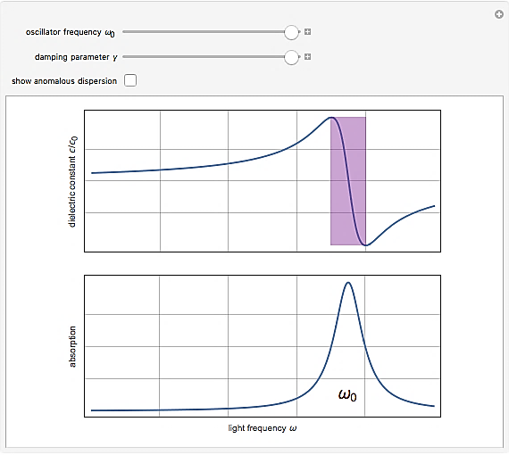

Figure 18

1. Gyrotropic Media: Landau-Lifshitz-Gilbert model (1955) describes the precessional motion of saturated magnetic dipoles in a magnetic field [Parson].

$$\frac{dM_{n}}{dt}=b_{n}×\left(-σ_{n}H+ω_{n}M_{n}+α_{n}\frac{dM_{n}}{dt}\right)-γ_{n}M_{n} ()$$

$M_{n}$ describes the linear deviation of magnetization from its static equilibrium value. Precession occurs around this unit bias vector $b_{n}$. $σ_{n}$ couples the polarization to the driving field, $ω_{n}$ is the angular resonance frequency, $γ_{n}$ is a damping factor.

|  |  |  |  |  |
| --- | --- | --- | --- | --- |
| **Property** | **Symbol** | **Standard Scale in SI Units** | **Conversion Factor** | **Normalized MEEP Units** |
| **Length** | $$a_{0}$$ | 1.00000e-3 m | $\frac{1}{a_{0}}$ = 1.00000e3 | 1 |
| **Speed of Light** | $$c_{0}$$ | 2.99792e8 $\frac{m}{s}$ | $\frac{1}{c_{0}}$ = 3.33564e-9 | 1 |
| **Current** | $$I_{0}$$ | 1.00000 A | $\frac{1}{I_{0}}$ = 1.00000 | 1 |
| **Time** | $$t_{0}$$ | $\frac{a_{0}}{c_{0}}$ = 3.33564e-12 s | $\frac{1}{t_{0}}$ = 2.99792e+11 | 1 |
| **Frequency** | $$f_{0}$$ | $\frac{c_{0}}{a_{0}}$ = 2.99792e+11 Hz | $\frac{1}{f_{0}}$ = 3.33564e-12 | 1 |
| **Permittivity** | $$ε_{0}$$ | 8.85418e-12 $\frac{F}{m}$ | $\frac{1}{ε_{0}}$ = 1.12940e+11 | 1 |
| **Permeability** | $$μ_{0}$$ | 1.25663e-6 $\frac{H}{m}$ | $\frac{1}{μ_{0}}$ = 7.95774e5 | 1 |
| **Electric Field Intensity** | $$E_{0}$$ | $\frac{I_{0}}{a_{0}ε_{0}c_{0}}$ = 3.76730e5 $\frac{V}{m}$ | $\frac{1}{E_{0}}$ = 2.65441e-6 | 1 |
| **Electric Flux Density** | $$D_{0}$$ | $\frac{I_{0}}{a_{0}c_{0}}$ = 3.33564e-6 $\frac{C}{m^{2}}$ | $\frac{1}{D_{0}}$ = 2.99792e5 | 1 |
| **Magnetic Field Intensity** | $$H_{0}$$ | $\frac{I_{0}}{a_{0}}$ = 1.00000e3 $\frac{A}{m}$ | $\frac{1}{H_{0}}$ = 1.00000e-3 | 1 |
| **Magnetic Flux Density** | $$B_{0}$$ | $\frac{I_{0}}{a_{0}ε_{0}c_{0}c_{0}}$ = 1.25663e-3 $\frac{Wb}{m^{2}}$ | $\frac{1}{B_{0}}$ = 7.95774e2 | 1 |
| **Electric Conductivity** | $$σ_{0}$$ | $\frac{ε_{r}ε_{0}c_{0}}{a_{0}}$ = 2.65441 $\frac{A}{Vm}$ | $\frac{1}{σ_{0}}$ = 3.7673e-1 | 1 |
| **Electric Current Density** | $$J_{0}$$ | $\frac{I_{0}}{a_{0}a_{0}}$ = 1.00000e6 $\frac{A}{m^{2}}$ | $\frac{1}{J_{0}}$ = 1.00000e-6 | 1 |
| **Energy Density** | $$U_{0}$$ | $\frac{I_{0}I_{0}}{a_{0}a_{0}ε_{0}c_{0}c_{0}}$ = 1.25663 $\frac{J}{m^{3}}$ | $\frac{1}{U_{0}}$ = 7.95774e-1 | 1 |
| **Poynting Vector** | $$S_{0}$$ | $\frac{I_{0}I_{0}}{a_{0}a_{0}ε_{0}c_{0}}$ = 3.76730e8 $\frac{W}{m^{2}}$ | $\frac{1}{S_{0}}$ = 2.65441e-9 | 1 |
| **Courant Factor** | $$S_{c0}$$ | $\frac{1}{c_{0}}$ = 3.33564e-9 $\frac{s}{m}$ | $\frac{1}{S_{c0}}$ = 2.99792e8 | 1 |

# Magnetic Transmission Line Simulation

This section

The Electromagnetic simulations will be carried out in MEEP [Oskooi] Simulator which is a script based Finite Difference Time Domain [Li] [Brignone] Electromagnetic Fields Simulator for solving Maxwell’s Equations [Paul]. MEEP [Oskooi] is ideal for modeling the time domain [Sui] and frequency domain behavior of a variety of arbitrary materials including anisotropic, dispersive [Deng], non-linear dielectrics [Nitu], electric/ magnetic conductors, media with saturable gain/ absorption, and gyrotropic media [Parson]. This simulator is well suited for Finite Difference Electromagnetic simulation [Li] [Brignone] of non-uniform, dispersive [Deng] Magnetic Transmission Lines [Faria] exhibiting complex permittivity and permeability [Al-Barqawi]. The C++ interface has the features of variable resolution and normalized units. Each spatial unit is modeled as a Yee’s Cell. This is ideal for modeling nonlinear [Macías-Díaz] [Sui], anisotropic, inhomogeneous media. Also, sample data for several materials is provided in libraries for building accurate test structures. The space is divided into independent chunks so that the program can be run on parallel processors. The boundaries can be modeled as perfectly matched layers to prevent reflection of fields. Hence, a wide variety of electric or magnetic current sources can be simulated. The program is solved for all Electric and Magnetic field components. Many derived components can be evaluated like Curl, Divergence, Energy Density, Potential, Flux, Poynting vector etc. Several Mathematical operations like averaging, symmetry and integration over a line, surface or volume are allowed in cylindrical and rectangular coordinates. The fields can be printed as image or video files as well. A frequency domain solver is also provided for multidimensional Laplace transformation and the decomposition of fields into travelling modes.

Lumped circuits [Edwards] are used for studying linear, time invariant, distributed systems like Magnetic Transmission Lines [Faria]. The distributed parameters can be calculated using mathematical formulas. MATLAB will be used for modeling the time and frequency domain behavior of Magnetic Transmission Lines [Faria] in terms of simplified Lumped Circuits.

Finite Difference Time Domain [Li] [Brignone] Electromagnetic Field MEEP [Oskooi] Simulations will be carried out for dispersive [Deng] Magnetic Transmission Lines [Faria] in anisotropic, inhomogeneous, non-linear media [Sui]. The Magnetic Transmission Lines [Faria] will be constructed using Drude-Lorentz susceptibility models for ferromagnetic conductors like Nickel, Iron and Cobalt alloys. The Transmission Lines will be excited using continuous point sources. The terminations can be modeled by Perfectly matched layers for Surge Impedance Loading; or as perfect reflectors for no load. Different Transmission Line structures can be simulated like the Wideband Transformer [Gustavsen] [Grecki] [Darraji] [Dinulovic] and Transmission Line Transformer [Mack].

In order to study their frequency response to continuous sources, Finite Difference Frequency Domain [Al-Barqawi] Electromagnetic Field MEEP [Oskooi] Simulations will be carried out. The multi-dimensional Fourier transform and mode decomposition will be used for this study. In order to simplify analysis, the Distributed System will be linearized to obtain a lumped model. The frequency Domain Behavior will also be studied using Transfer Function of Equivalent T-model Transmission Line circuit.

Multi-conductor Transmission Lines introduce many complexities like capacitive/ inductive coupling. MEEP [Oskooi] Simulations and MATLAB Lumped Circuit Simulations [Edwards] will be carried out for studying cross talk between Conductors of multi-wire Magnetic Transmission Lines.

As in the case of Electric Transmission Lines, Power Flow Equations can be developed for Magnetic Transmission Lines [Faria] in terms of Lumped parameters; like per unit length transverse impedance and the per unit length longitudinal admittance. The results can be verified using electromagnetic simulations.

The Electromagnetic MEEP [Oskooi] Simulations will help to probe the stored Electric/ Magnetic Energy Density, geometric parameters, per unit length losses and Transmission Efficiency of Magnetic Transmission Lines. Among the different magnetic materials, the best alloy will be chosen based on desired performance metrics. A suitable candidate must exhibit minimal radiation and line losses. The transverse impedance and longitudinal admittance dictate the propagation of wave modes in magnetic transmission lines [Faria]. Simulations will be used to estimate per unit length transverse inductance and longitudinal capacitance, which contribute to the transverse impedance and longitudinal admittance respectively. These parameters are pivotal in determining the lumped model of the distributed Transmission Line system.

The Magnetic Transmission Lines [Faria] will be excited by continuous sources to examine their Frequency Response. The Fourier Transform will decompose the Fields into the various travelling wave modes. This will aid the study of the effects of magnetic hysteresis [Macías-Díaz] [Luo] and saturation on power quality [9]. The T-model Equivalent Magnetic circuits [Edwards] and coupled equations will be used to simplify analysis of the transient [Brignone] and steady state behavior. According to theory, Magnetic Transmission Lines [Faria] must exhibit the behavior of a high pass filter, blocking all DC signals. DC signals produce the most severe transients in Electric Transmission Lines [Brignone]; which behave like a low pass filter. However, this also implies that Magnetic Transmission Lines [Faria] must be operated at higher frequencies than Electric Transmission Lines. Poorly designed Magnetic Transmission Lines [Faria] may amplify high frequency noise which can be damaging for the power system. The imaginary part of Transmission Line Magnetic Reluctance, which is a strong function of frequency, contributes to line losses. Hysteresis losses [Macías-Díaz] [Luo] also increase significantly at higher frequencies [Erickson] [9]. Hence, an appropriate frequency must be chosen, considering the complex nature of the magnetic material.

The study of capacitive/ inductive coupling in Multi-Conductor Transmission Lines will provide useful knowledge about the Radiated/ Conducted Emissions and Susceptibility. The generator-receptor model is well suited for studying Electromagnetic Interference and Electromagnetic Compatibility of Magnetic Transmission Lines [Faria]. The results can be compared with mathematical formulas to build linear circuit models [Edwards] for cross talk between Magnetic Transmission Lines [Faria]. The aim will be to minimize Electromagnetic Radiation; that can be picked up by intentional receivers like Radio and Television; or unintentional receivers like digital Computers. This will prevent malfunction of the sensitive electronic equipment.

Power Flow Equations for Magnetic Transmission Lines [Faria] will help to compare the Electromagnetic and Magnetic circuit models. The Power Flow will be represented in the form of Magnetic Current and Magnetic Voltage for circuit Model. For the Electromagnetic Model, the Power Flow will be represented in the form of Magnetic Field and Electric Field. Accurate Estimation of Lumped parameters; like per unit length transverse impedance and the per unit length longitudinal admittance is necessary for producing a valid lumped magnetic circuit [Edwards] for Magnetic Transmission Lines [Faria].

**Longitudinal Fields**

|  |  |  |  |
| --- | --- | --- | --- |
|  | x | y | Z |
| H | D:\New folder\MGTL\Thesis\Codes\Code43\Logitudinal\hx-000050.25.png | D:\New folder\MGTL\Thesis\Codes\Code43\Logitudinal\hy-000050.25.png | D:\New folder\MGTL\Thesis\Codes\Code43\Logitudinal\hz-000050.25.png |
| B | D:\New folder\MGTL\Thesis\Codes\Code43\Logitudinal\bx-000050.25.png | D:\New folder\MGTL\Thesis\Codes\Code43\Logitudinal\by-000050.25.png | D:\New folder\MGTL\Thesis\Codes\Code43\Logitudinal\bz-000050.25.png |
| E | D:\New folder\MGTL\Thesis\Codes\Code43\Logitudinal\ex-000050.25.png | D:\New folder\MGTL\Thesis\Codes\Code43\Logitudinal\ey-000050.25.png | D:\New folder\MGTL\Thesis\Codes\Code43\Logitudinal\ez-000050.25.png |
| D | D:\New folder\MGTL\Thesis\Codes\Code43\Logitudinal\dx-000050.25.png | D:\New folder\MGTL\Thesis\Codes\Code43\Logitudinal\dy-000050.25.png | D:\New folder\MGTL\Thesis\Codes\Code43\Logitudinal\dz-000050.25.png |
| S | D:\New folder\MGTL\Thesis\Codes\Code43\Logitudinal\sx-000050.25.png | D:\New folder\MGTL\Thesis\Codes\Code43\Logitudinal\sy-000050.25.png | D:\New folder\MGTL\Thesis\Codes\Code43\Logitudinal\sz-000050.25.png |

**Transverse Fields**

|  |  |  |  |
| --- | --- | --- | --- |
|  | x | y | Z |
| H | D:\New folder\MGTL\Thesis\Codes\Code43\Transverse\hx-000050.25.png | D:\New folder\MGTL\Thesis\Codes\Code43\Transverse\hy-000050.25.png | D:\New folder\MGTL\Thesis\Codes\Code43\Transverse\hz-000050.25.png |
| B | D:\New folder\MGTL\Thesis\Codes\Code43\Transverse\bx-000049.25.png | D:\New folder\MGTL\Thesis\Codes\Code43\Transverse\by-000050.25.png | D:\New folder\MGTL\Thesis\Codes\Code43\Transverse\bz-000049.25.png |
| E | D:\New folder\MGTL\Thesis\Codes\Code43\Transverse\ex-000049.25.png | D:\New folder\MGTL\Thesis\Codes\Code43\Transverse\ey-000050.25.png | D:\New folder\MGTL\Thesis\Codes\Code43\Transverse\ez-000050.25.png |
| D | D:\New folder\MGTL\Thesis\Codes\Code43\Transverse\dx-000050.25.png | D:\New folder\MGTL\Thesis\Codes\Code43\Transverse\dy-000050.25.png | D:\New folder\MGTL\Thesis\Codes\Code43\Transverse\dz-000049.25.png |
| S | D:\New folder\MGTL\Thesis\Codes\Code43\Transverse\sx-000050.25.png | D:\New folder\MGTL\Thesis\Codes\Code43\Transverse\sy-000050.25.png | D:\New folder\MGTL\Thesis\Codes\Code43\Transverse\sz-000049.25.png |

## Wideband Transformers

Wideband Transformers [Gustavsen] [Grecki] [Dinulovic] are widely used in RF Electronics for voltage, current and impedance matching of unbalanced loads [Darraji]. They provide DC isolation and common mode rejection for efficient AC transmission.

Wideband Transformers [Grecki] provide impedance matching for interfacing different systems through accurate current and voltage transformation [Darraji]. The impedance transformation ratio is dictated by the square of the effective turns ratio between the primary and secondary side [Gustavsen].

Unlike an unbalanced network, a balanced network has none of its terminals connected to ground. It is difficult to interface balanced systems with unbalanced systems due to common mode currents [Gustavsen]. Balun transformer is used for providing DC isolation and maximum power transfer between a balanced and an unbalanced system. A Unun transformer is used for interfacing two unbalanced impedances, whereas a Balbal transformer connects two balanced systems [Darraji].

Usually wideband transformers [Grecki] are required in high frequency communication applications that require processing of small amounts of RF power in a wide frequency range [Dinulovic] [Darraji] [Gustavsen]. For high power applications in Base Station Amplifiers, Repeaters, Satellites, Radar and VFDs, the power limitations of the core and winding must be controlled along with the parasitic losses [Gustavsen] [Erickson].

1. Telecommunication Applications: 4G, CDMA, EDGE, GSM, LMDS, LTE, MMDS, Handsets (Cellular, PHS, DECT, TV), Node B, Pagers, TD-SCDMA, TMA, UMTS, W-CDMA, Wi-Fi, WiMAX, Wireline (DSL, ADSL, DSLAM etc.), W-LAN, WLL.
2. Automotive Applications: IVHS, GPS, Tracking
3. Wireless Communication: Audio Systems, AMR, EPIRB, Marine Radar, Marine GPS, RFID Reader/ TAGS, Security Monitoring Systems, Radio Astronomy, Jammers.
4. STATCOM: DBS, LNBs, MODEMs, TMBs, V-SAT.
5. Medical Applications: CT, MR, Ultrasound, Telemetry.
6. Cable/ CATV and Broadband Fiber Communication: BPON, Cable (Set Top Box), Fiber Optic, FTTH, GPON, Hybrid Fiber Coax Network, MOCA.
7. Broadcast Applications: Radio, TV, LMDS.
8. Avionics: Radar, Surveillance Radar, MLS, TACAN, TCAS.

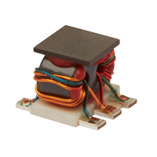

Figure 19

The performance of a wideband transformer [Grecki][Darraji] [Dinulovic] can be analyzed by the following performance parameters:

1. Bandwidth [Gustavsen]: The range of frequencies between the two maximum allowable attenuation (1 dB/ 2 dB/ 3 dB) points fmin and fmax. A high fractional bandwidth $\frac{f_{max}}{f_{min}}$ of 1000 or more can only be achieved if the primary and secondary windings are strongly coupled [Grecki]. Besides attenuation, wideband transformer may also introduce undesirable phase noise in the system causing distortion of RF signal. The transformer must be designed to have a flat phase response in the desired frequency range [Gustavsen].
2. Insertion Loss: The ratio of power transfer between the source and an ideal load upon direct connection; and when the transformer is used for the connection. It is indicative of the power loss through the transformer under matched conditions [Gustavsen]. For a typical wideband transformer, the insertion loss increases at low frequencies due to the low magnetizing reactance [Grecki]. At high frequencies, the insertion loss increases due to the inter-winding capacitance and the leakage inductance [Grecki] [Erickson]. Often, mid-band insertion loss (e.g. 0.5 dB) is taken as reference value [Gustavsen].
$$Insertion Loss= 20 \log_{10}\frac{V_{Load}(Direct connection between source and ideal load)}{V_{Load }(Transformer inserted between source and ideal load)}()$$

3. Return Loss: The ratio of applied power and reflected power due to impedance mismatch between the source and load [Gustavsen]. Optimal impedance matching must maximize the return loss (e.g. 14 - 25 dB) over the entire operational bandwidth i.e. minimum input power must be reflected back to the source [Grecki].
$$Return Loss= 20 \log_{10}\frac{P_{applied}}{P_{reflected}} ()$$

4. Amplitude balance: The absolute difference in signal amplitude between the outputs of a center-tapped transformer [Grecki] [Gustavsen].
5. Phase balance: The absolute difference in signal phase between the outputs of a center-tapped transformer [Grecki] [Gustavsen].

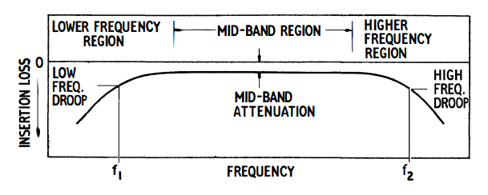

Figure 20

## Electrical Circuit for Wideband Transformer

The equivalent electrical circuit diagram of a wideband transformer [Gustavsen] [Dinulovic] [Darraji] is given below.

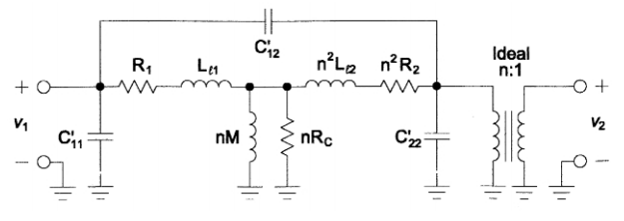

Figure 21

$L_{l1}$ represents the primary leakage inductance.

$n^{2}L_{l2}$ represents the secondary leakage inductance referred to the primary side.

$R_{1}$ represents the primary winding resistance.

$n^{2}R_{2}$ represents the secondary winding resistance referred to the primary side.

$nR_{c}$ is the shunt resistance representing core loss.

nM is the magnetizing inductance of the core.

$C_{11}^{'}$ is the shunt capacitance associated with the primary windings.

$C_{22}^{'}$ is the shunt capacitance associated with the secondary windings.

$C_{12}^{'}$ is the capacitance between the primary and secondary windings.

The operation of wideband transformer [Grecki] [Dinulovic] [Darraji] can be divided into three distinct segments:

1. Low Frequency Region: The low frequency droop in the transfer characteristics is attributed to the diminishing shunt magnetizing reactance [Gustavsen] [Grecki]. The loss can be reduced by inserting capacitance in series with the primary or secondary winding [Gustavsen].
2. Mid-band Region: The parasitic inductances and capacitances can be ignored in the mid-band region [Gustavsen]. The response is mainly effected by the series resistance of the windings and the shunt resistance of the core [Grecki].
3. High Frequency Region: The high frequency droop results from the losses in leakage inductances and shunt capacitances of the windings [Gustavsen]. The reactance of leakage inductances increases greatly whereas the reactance of shunt capacitance decreases at high frequencies [Grecki].

## Magnetic Circuit for Wideband Transformer

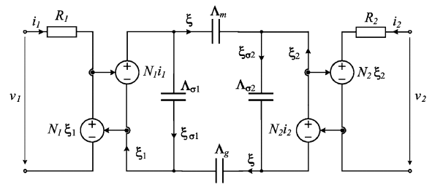

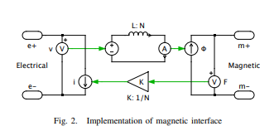

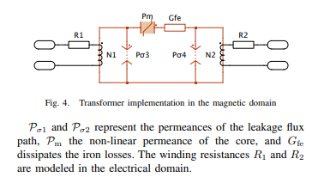

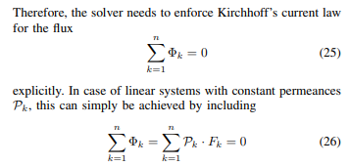

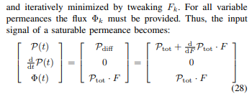

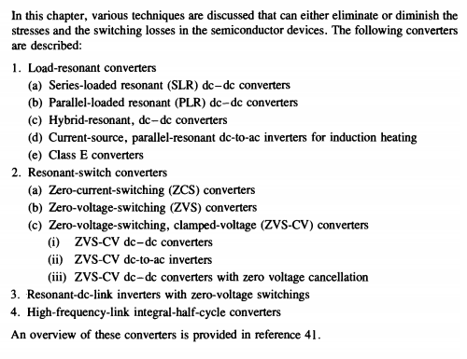

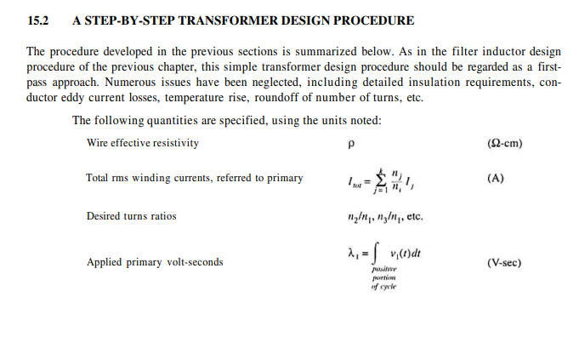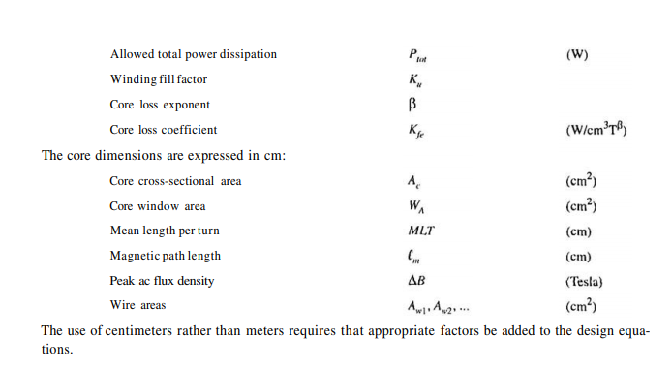

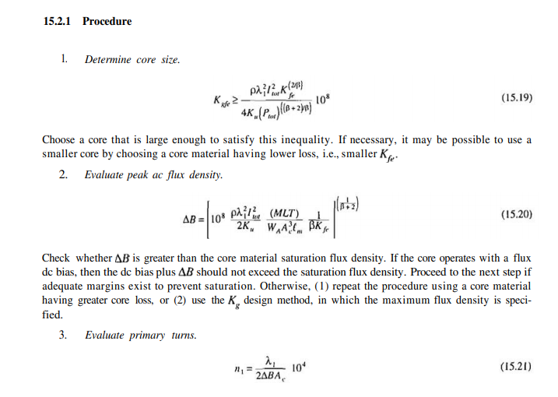

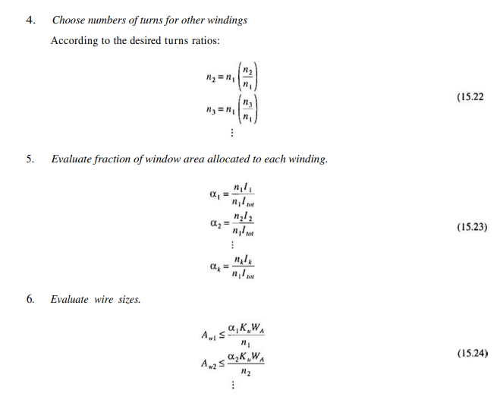

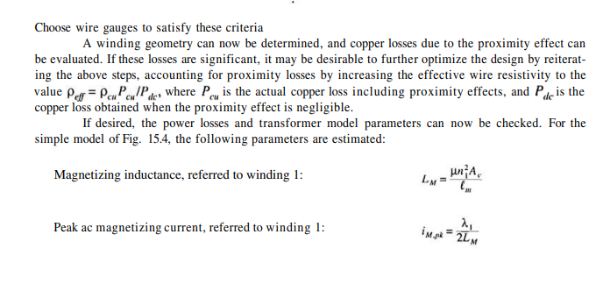

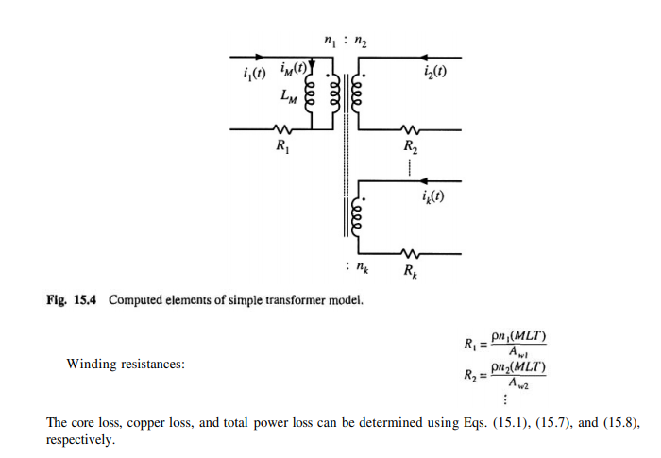



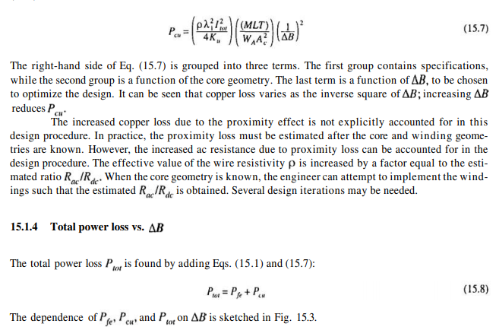

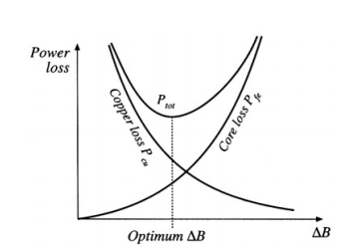

## Wideband Transformer Simulation in MEEP

* The Magnetic Transmission Lines [Faria] will be constructed for inhomogeneous, dispersive [Deng], non-linear ferromagnetic conductors [Bragg] like Ferromagnetic, Permalloy and Cobalt alloys.
* The Transmission Lines will be excited using continuous current sources.
* The terminations can be modeled by Perfectly matched layers for complete absorption; or as perfect reflectors for no load.
* Different Transmission Line structures can be simulated like shielded transmission line and multi-wire transmission lines.
* The multi-dimensional discrete Fourier transform (1822) and mode decomposition will be used to determine the Absorbance, Transmittance and Broadband Response [Lehr] [Nitu].
* A wideband transformer [Grecki] [Darraji] [Dinulovic] passes a frequency band of several decades and are usually designed to handle complex waveforms like rectangular pulses [Lehr]. They are used for impedance matching, voltage/ current transformation, DC isolation, mixing, power splitting, coupling and signal inversion [Gustavsen].
* A wideband transformer [Darraji] [Dinulovic] will be simulated. It will be excited by a small pulse to examine the Frequency Response [Lehr]. The 3 dimensional discrete Fourier Transform will be used to determine Absorbance, Transmittance and Broadband Response [Lehr] [Nitu] [Dinulovic] [Grecki] [Gustavsen]. The results can be compared with published datasheet.

Figure 22

The Loss tangent $tanδ$ has the following components:

* DC Resistance Loss Tangent $tanδ_{dc}$
* Skin Effect Loss Tangent $tanδ_{se}$
* Proximity Effect Loss Tangent $tanδ_{pe}$
* Self Capacitance Dielectric Loss Tangent $tanδ_{cp}$
* Self Capacitance Circulating Currents Loss Tangent $tanδ_{cs}$
* Core Residual Loss Tangent $tanδ_{r}$
* Core Eddy Current Loss Tangent $tanδ_{f}$, $P_{e}=\frac{{(πfτB_{max})}^{2}V}{6ρ}$
* Core Hysteresis Loss Tangent $tanδ_{h}$, $P_{h}=ηVfB_{max}^{n}$

Non-linear components must be used for these complex effects. Network Equivalent Magnetic circuits [Edwards] and coupled equations will be used to simplify analysis of the transient [Brignone] and steady state behavior.

* Magnetic coupling between magnetic transmission lines [Faria] results in sharing of electromagnetic energy. This division of power is very useful in design of Radio frequency devices like sensors [Ripka], antennas and communication systems [Darraji].
* Magnetic Coupling is also very important in the working of DC and AC machines like induction motor, hysteresis motor and Reluctance motor [Erickson].
* The study of capacitive/ inductive coupling in Multi-Conductor Transmission Lines will provide useful knowledge about the Radiated/ Conducted Emissions and Radiated/ Conducted Susceptibility.
* The results can be compared with MATLAB linear circuit models for cross talk between Magnetic Transmission Lines [Faria].
* The aim will be to minimize Electromagnetic Radiation; that can be picked up by unintentional receivers like digital Computers.

The simulators can not be used to model the following magnetic effects:

1. Magnetostriction
2. Accoustic effects
3. Relativistic Effects
4. Piezomagnetism
5. Gravitomagnetism

**Longitudinal Fields**

|  |  |  |  |  |
| --- | --- | --- | --- | --- |
|  | x | Y | Z | Field Map |
| H | D:\New folder\MGTL\Thesis\Codes\Code46\MMTL-out\hx-005001.25.png | D:\New folder\MGTL\Thesis\Codes\Code46\MMTL-out\hy-005001.25.png | D:\New folder\MGTL\Thesis\Codes\Code46\MMTL-out\hz-005001.25.png |  |
| B | D:\New folder\MGTL\Thesis\Codes\Code46\MMTL-out\bx-005001.25.png | D:\New folder\MGTL\Thesis\Codes\Code46\MMTL-out\by-005001.25.png | D:\New folder\MGTL\Thesis\Codes\Code46\MMTL-out\bz-005001.25.png |  |
| E | D:\New folder\MGTL\Thesis\Codes\Code46\MMTL-out\ex-005001.25.png | D:\New folder\MGTL\Thesis\Codes\Code46\MMTL-out\ey-005001.25.png | D:\New folder\MGTL\Thesis\Codes\Code46\MMTL-out\ez-005001.25.png |  |
| D | D:\New folder\MGTL\Thesis\Codes\Code46\MMTL-out\dx-005001.25.png | D:\New folder\MGTL\Thesis\Codes\Code46\MMTL-out\dy-005001.25.png | D:\New folder\MGTL\Thesis\Codes\Code46\MMTL-out\dz-005001.25.png |  |

Frequency Response of Poynting Flux at Sending End and Receiving end is used to determine the transmission spectrum.





Decay of Electric/ Magnetic Voltage and Current along the length of the Magnetic path.



Skin Effect in Magnetic wire



Intrinsic Impedance of Magnetic Transmission Line

1GHz



Resistivity=1e9



Propagation Constant





# Conclusion

The conventional reluctance model is not accurate for the modeling of magnetic circuits [Edwards]. It must be replaced by Magnetic Transmission Line Model [Faria] for accurate modeling of such inhomogeneous, dispersive [Deng], non-linear [Bragg] structures.

The power invariant Magnetic Transmission Line model [Faria] can also be used for accurate modeling of

* AC and DC Machines [Erickson]
* Micro-strip Antennas
* Gyromagnetic NLTLs [Romanchenko] [Parson]
* Magnetic Transistors and Magnetic Microprocessors

# References

[1] H. Al-Barqawi, N. Dib and M. Khodier, “A Full-Wave Two-Dimensional Finite-Difference Frequency-Domain Analysis of Ferrite-Loaded Structures”. Mosharaka International Conference on Communications, Propagation and Electronics, 2008.

[2] J. Allmeling, W. Hammer, and J. Schonberger, “Transient simulation of magnetic circuits using the permeance-capacitance analogy,” *2012 IEEE 13th Workshop on Control and Modeling for Power Electronics (COMPEL)*, 2012.

[3] B. Anderson and R. Newcomb, “A capacitor-transformer gyrator realization,” *Proceedings of the IEEE*, vol. 53, no. 10, 1965.

[4] G. Antonini, A general framework for the analysis of metamaterial transmission lines. Prog.Electromagn. Res. B., pp. 353–373, 2010.

[5] J. Atulasimha and S. Bandyopadhyay, Nanomagnetic and Spintronic Devices for energy-efficient memory and computing. Chichester, West Sussex: Wiley, 2016.

[6] S. Blundell, *Magnetism in condensed matter*. Oxford: Oxford University Press, 2014.

[7] J. Bragg, J. Dickens, and A. Neuber, “Material selection considerations for coaxial, ferrimagnetic-based nonlinear transmission lines,” *Journal of Applied Physics*, vol. 113, no. 6, 2013.

[8] M. Brignone, D. Mestriner, R. Procopio, A. Piantini, and F. Rachidi, “On the Stability of FDTD-Based Numerical Codes to Evaluate Lightning-Induced Overvoltages in Overhead Transmission Lines,” *IEEE Transactions on Electromagnetic Compatibility*, vol. 62, no. 1, pp. 108–115, 2020.

[9] C. Caloz and T. Itoh, Electromagnetic Metamaterials: Transmission Line Theory and Microwave Applications, Wiley-IEEE Press, pp. 27-58, 2006.

[10] S. Chua, Y. Chong, A. D. Stone, M. Soljacic and J. Bravo-Abad, “Low-threshold lasing action in photonic crystal slabs enabled by Fano resonances” Optics Express, vol. 19, no. 2, 2011.

[11] G. Cividjian, “Corner 2D Capacitance,” *2018 20th International Symposium on Electrical Apparatus and Technologies (SIELA)*, 2018.

[12] R. Darraji, M. Honari, R. Mirzavand, F. Ghannouchi, and P. Mousavi, “Wideband Two-Section Impedance Transformer With Flat Real-to-Real Impedance Matching,” *IEEE Microwave and Wireless Components Letters*, vol. 26, no. 5, pp. 313–315, 2016.

[13] S. Demokritov, Magnonics: From Fundamentals to Applications. Berlin: Springer, 2013.

[14] T. Deng and Z. Chen, “Design of frequency-dispersive magnetic material for application of microwave attenuation,” *2016 46th European Microwave Conference (EuMC)*, 2016.

[15] D. Dinulovic, M. Shousha, M. Haug, and K. Shafey, “Miniaturized Planar Transformer Embedded in Ferrite Substrate for Isolated High- Frequency Low-Power Applications,” *2019 20th International Symposium on Power Electronics*, 2019.

[16] T. Edwards and M. Steer, Foundations for Microstrip Circuit Design, 4th ed. Wiley-IEEE Press, pp. 576-607, 2016.

[17] I. Eichwald, S. Breitkreutz, G. Ziemys, G. Csaba, W. Porod, and M. Becherer, “Majority logic gate for 3D magnetic computing,” *Nanotechnology*, vol. 25, no. 33, 2014.

[18] R. Erickson, D. Maksimovic, *Fundamentals of Power Electronics*, 2nd ed. Kluwer, 2004.

[19] L. Er-Ping, Computational Electromagnetics for Electromagnetic Compatibility/ Signal Integrity Analysis, IEEE EMC DL Talk, University of Missouri, 2008.

[20] J. Faria, Multimodal propagation in multiconductor transmission lines. J. Electromag. Waves Appl. 2014.

[21] J. Faria, Formulation of Multiwire Magnetic Transmission-Line Theory, Progress in Electromagnetics Research B, Vol. 49, 2013.

[22] J. Faria, Matrix theory of wave propagation in hybrid electric/magnetic multiwire transmission line systems, Journal of Electromagnetic Waves and Applications, Vol. 29, No. 7, 2015.

[23] J. Faria, A physical model of the ideal transformer based on magnetic transmission line theory, Journal of Electromagnetic Waves and Applications, Vol. 27, No. 3, 2013.

[24] J. Faria, Electromagnetic Foundations of Electrical Engineering, Chichester: John Wiley and Sons, 2008.

[25] A. Goldman, Modern Ferrite Technology, New York, NY: Springer, 2010.

[26] G. González and M. Ehsani, “Power-Invariant Magnetic System Modeling,” *International Journal of Magnetics and Electromagnetism*, vol. 4, no. 1, pp. 1–9, Dec. 2018.

[27] F. Grecki and B. Wunsch, “Validation of Power Transformer Wideband Modeling Using standard sFRA method with VNA Equipment,” *2019 IEEE PES Asia-Pacific Power and Energy Engineering Conference (APPEEC)*, 2019.

[28] A. Guimaraes, Principles of Nanomagnetism. Cham: Springer, 2018.

[29] B. Gustavsen, “A hybrid measurement approach for wide-band characterization and modeling of power transformers,” *2011 IEEE Power and Energy Society General Meeting*, 2011.

[30] D. Hamill, “Gyrator-capacitor modeling: a better way of understanding magnetic components,” *Proceedings of 1994 IEEE Applied Power Electronics Conference and Exposition - ASPEC94*,1994.

[31] V. Harris, “Modern Microwave Ferrites,” *IEEE Transactions on Magnetics*, vol. 48, no. 3, pp. 1075–1104, 2012.

[32] M. Holynska, Single-Molecule Magnets: Molecular Architectures and Building Blocks for Spintronics. Newark: John Wiley and Sons, 2019.

[33] “IEEE Guide for Loss Evaluation of Distribution and Power Transformers and Reactors," in IEEE Std C57.120-2017 (Revision of IEEE Std C57.120-1991), vol., no., pp.1-53, 18 Oct. 2017.

[34] “IEEE Standard for Pulse Transformers," in ANSI/IEEE Std 390-1987, vol., no., pp.1-32, 14 Oct. 1987.

[35] “IEEE Recommended Practice for Validation of Computational Electromagnetics Computer Modeling and Simulations," in IEEE Std 1597.2-2010, vol., no., pp.1-124, 25 Feb. 2011.

[36] M. Imtaar, P. Li, E. Varga, G. Csaba, G. Bernstein, G. Scarpa, W. Porod, and P. Lugli, “Nanomagnetic logic devices fabrication using nanoimprint lithography,” *2013 13th IEEE International Conference on Nanotechnology (IEEE-NANO 2013)*, 2013.

[37] W. Sui, Time Domain Computer Analysis of Nonlinear Hybrid Systems, pp. 251-283, 2018.

[38] S. Karelin, “FDTD analysis of nonlinear magnetized ferrites: application to modeling of oscillation forming in coaxial line with ferrite,” *Radiofizika I Elektronika*, vol. 22, no. 1, pp. 51–56, 2017.

[39] A. Khitun and A. Kozhanov, “Magnonic Logic Devices,” *Nanomagnetic and Spintronic Devices for Energy-Efficient Memory and Computing*, pp. 189–219, May 2016.

[40] M. Leuenberger and D. Loss, “Quantum computing in molecular magnets,” *Nature*, vol. 410, no. 6830, pp. 789–793, 2001.

[41] Y. Li, X. Li, and J. Mao, “Time domain analysis of transmission line based on WLP-FDTD,” *2013 IEEE International Wireless Symposium (IWS)*, 2013.

[42] M. Luo, D. Dujic, and J. Allmeling, “Modelling hysteresis of soft core materials using permeance-capacitance analogy for transient circuit simulations,” *2017 19th European Conference on Power Electronics and Applications (EPE17 ECCE Europe)*, 2017.

[43] M. Luo, D. Dujic, and J. Allmeling, “Modeling Frequency Independent Hysteresis Effects of Ferrite Core Materials Using Permeance–Capacitance Analogy for System-Level Circuit Simulations,” *IEEE Transactions on Power Electronics*, vol. 33, no. 12, 2018.

[44] M. Luo, D. Dujic, and J. Allmeling, “Permeance based modeling of magnetic hysteresis with inclusion of eddy current effect,” *2018 IEEE Applied Power Electronics Conference and Exposition (APEC)*, 2018.

[45] R. A. Mack and J. Sevick, Sevick’s Transmission Line Transformers: Theory and practice, 5th ed. Edison, NJ: Scitech Publishing, 2014.

[46] J. Macías-Díaz, “Persistence of nonlinear hysteresis in fractional models of Josephson transmission lines,” *Communications in Nonlinear Science and Numerical Simulation*, vol. 53, pp. 31–43, 2017.

[47] A. Moryc and W. Gwarek, “An equivalent lumped circuit describing magnetized plasma and its application in FD-TD modeling,” *15th International Conference on Microwaves, Radar and Wireless Communications*, 2004.

[48] M. Nitu, M. Nicola, M. Duta, and M. Benea, “Methods for Determining Dielectric Stresses in the Windings of a Transformer Subjected to Lightning Impulse,” *2019 International Conference on Electromechanical and Energy Systems (SIELMEN)*, 2019.

[49] G. Nnachi, A. Akumu, C. Richards, and D. Nicolae, “Estimation of no-Load Losses in Distribution Transformer Design Finite Element Analysis Techniques in Transformer Design,” *2018 IEEE PES/IAS PowerAfrica*, 2018.

[50] A. Oskooi, D. Roundy, M. Ibanescu, P. Bermel, J. Joannopoulos, and S. Johnson, MEEP: A flexible free-software package for electromagnetic simulations by the FDTD method, Computer Physics Communications, Vol. 181, pp. 687-702, 2010.

[51] U. Ozgur, Y. Alivov, and H. Morkoc, “ChemInform Abstract: Microwave Ferrites. Part 2. Passive Components and Electrical Tuning,” *ChemInform*, vol. 41, no. 36, Dec. 2010.

[52] J. Parson, A. Neuber, J. Dickens and J. Mankowski, Investigation of a stripline transmission line structure for gyromagnetic nonlinear transmission line [Romanchenko] high power microwave sources, Review of Scientific Instruments, Vol. 87, pp. 1-7, 2016.

[53] C. Paul, K. Whites and S. Nasar, Introduction to electromagnetic fields, 4th ed. Boston: WCB/McGraw-Hill, pp.586-589, 1998.

[54] C. Paul, Introduction to Electromagnetic Compatibility, 2nd ed. Kentucky: John Wiley and Sons, pp. 559-710, 2006.

[55] C. Paul, Analysis of Multiconductor Transmission Lines, 2nd ed. Hoboken: Wiley-Interscience, pp. 240-342, 2008.

[56] D. Pozar, Microwave Engineering, 4nd ed. Kentucky: John Wiley and Sons, pp. 1-271, 2012.

[57] J. Lehr, P. Ron, Foundations of Pulsed Power Technology: John Wiley and Sons, pp. 63–96, Jul. 2017.

[58] P. Ripka and M. Janosek, “Advances in magnetic sensors,” *2008 IEEE Sensors*, 2008.

[59] I. Romanchenko, P. Priputnev, and V. Rostov, “RF pulse formation dynamics in gyromagnetic nonlinear transmission lines,” *Journal of Physics: Conference Series*, vol. 830, Apr. 2017.

[60] J. Rossi, F. Yamasaki, E. Schamiloglu, and J. Barroso, “Analysis of nonlinear gyromagnetic line operation using LLG equation,” *2017 IEEE 21st International Conference on Pulsed Power (PPC)*, 2017.

[61] K. Sato, E. Saitoh A. Willoughby and P. Capper, Spintronics for next generation Innovative Devices. John Wiley and Sons, 2015.

[62] J. Schneider, Understanding the Finite-Difference Time-Domain Method, p. 33-74, 2017.

[63] J. Sevick, R. Mack, Sevick’s Transmission Line Transformers Theory and Practice, 5th ed. SciTech Publishing, 2014.

[64] N. Shirdel, A. Akbari, H. Mirzaei, and M. Abrishamian, “Three-dimensional simulation of UHF signal propagation in transformer using FDTD method,” *2011 International Conference on Power Engineering, Energy and Electrical Drives*, 2011.

[65] R. Slatter, “High accuracy, high bandwidth magnetoresistive current sensors for spacecraft power electronics,” *2015 17th European Conference on Power Electronics and Applications (EPE15 ECCE-Europe)*, 2015.

[66] E. Snelling, Soft Ferrites: Properties and Applications. Mendham, NJ: PSMA, 2005.

[67] A. Taflove and S. Hagness, Computational Electrodynamics: The Finite-Difference Time-Domain Method, 3rd ed. Boston: Artech House, 2005.

[68] A. Taflove, A. Oskooi and S. Hagness, Advances in FDTD computational electrodynamics: photonics and nanotechnology, 3rd ed. Boston: Artech House, 2013, p. 567-592.

[69] N. Tiwari, A. Jha, S. Singh, and M. Akhtar, “Estimation of Broadband Complex Permeability using SIW Cavity based Multimodal Approach,” *IEEE Transactions on Instrumentation and Measurement*, 2020.

[70] M. Ulmasculov, K. Sharypov, S. Shunailov, V. Shpak, M. Yalandin, M. Pedos, and S. Rukin, “Gyromagnetic nonlinear transmission line generator of high voltage pulses modulated at 4 GHz frequency with 1000 Hz pulse repetition rate,” *Journal of Physics: Conference Series*, vol. 830, Apr. 2017.

[71] J. Xu, M. Koledintseva, Y. Zhang, Y. He, B. Matlin, R. Dubroff, J. Drewniak, and J. Zhang, “Complex Permittivity and Permeability Measurements and Finite-Difference Time-Domain Simulation of Ferrite Materials,” *IEEE Transactions on Electromagnetic Compatibility*, vol. 52, no. 4, 2010.

[72] H. Zhao, Y. Li, Q. Lin, and S. Wang, “The Parasitic Capacitance of Magnetic Components with Ferrite Cores Due to Time-Varying Electromagnetic (EM) Field,” *2018 IEEE Energy Conversion Congress and Exposition (ECCE)*, 2018.

[73] D. Zyatkov, A. Yurchenko, and E. Yurchenko, “Capacitive sensor of weak magnetic field on the basis of feromagnetic fluid with micro- and nanoscale particles,” *Progress In Electromagnetics Research Symposium - Spring (PIERS)*, 2017.

[74] D. Zyatkov, V. Balashov, V. Yurchenko, V. Cherepanov, and Z. Kochnev, “Capacitive Sensing Element with a Magnetic Fluid for Detecting of Change of Magnetic Field,” *2019 Photonics & Electromagnetics Research Symposium - Spring (PIERS-Spring)*, 2019.

# Appendix